Subject | Film and Media Studies
Level | LEVEL 3
Qualification | A-level Film and Media Studies
Exam board / awarding body | AQA
Part of the Creative Media Practice course is to understand and analyse why certain media techniques have been used throughout the industry. In order to create the best work possible on the course, you must be engrossed in all things media and understand why they have been done.
“Nothing is original. Steal from anywhere that resonates with inspiration or fuels your imagination. Devour old films, new films, music, books, paintings, photographs, poems, dreams, random conversations, architecture, bridges, street signs, trees, clouds, bodies of water, light and shadows. Select only things to steal from that speak directly to your soul.” - Jim Jarmusch
During the Media course, we’ll explore the workings of highly influential practitioners and discuss their work in depth and detail before creating our own. In order to find your niche and your passion, you must first discover work that inspires you.
Task 1: Watch the following video that explains how cinematography works and how to analyse it.
https://www.youtube.com/watch?v=YEuGCB0_v6Y
Task 2: Watch some of your favourite films and screen shot some 3 frames that you find inspiring with the use of cinematography. With those screen shots, break down an analysis of that frame, thinking about why certain techniques have been used. I have added my own example below.
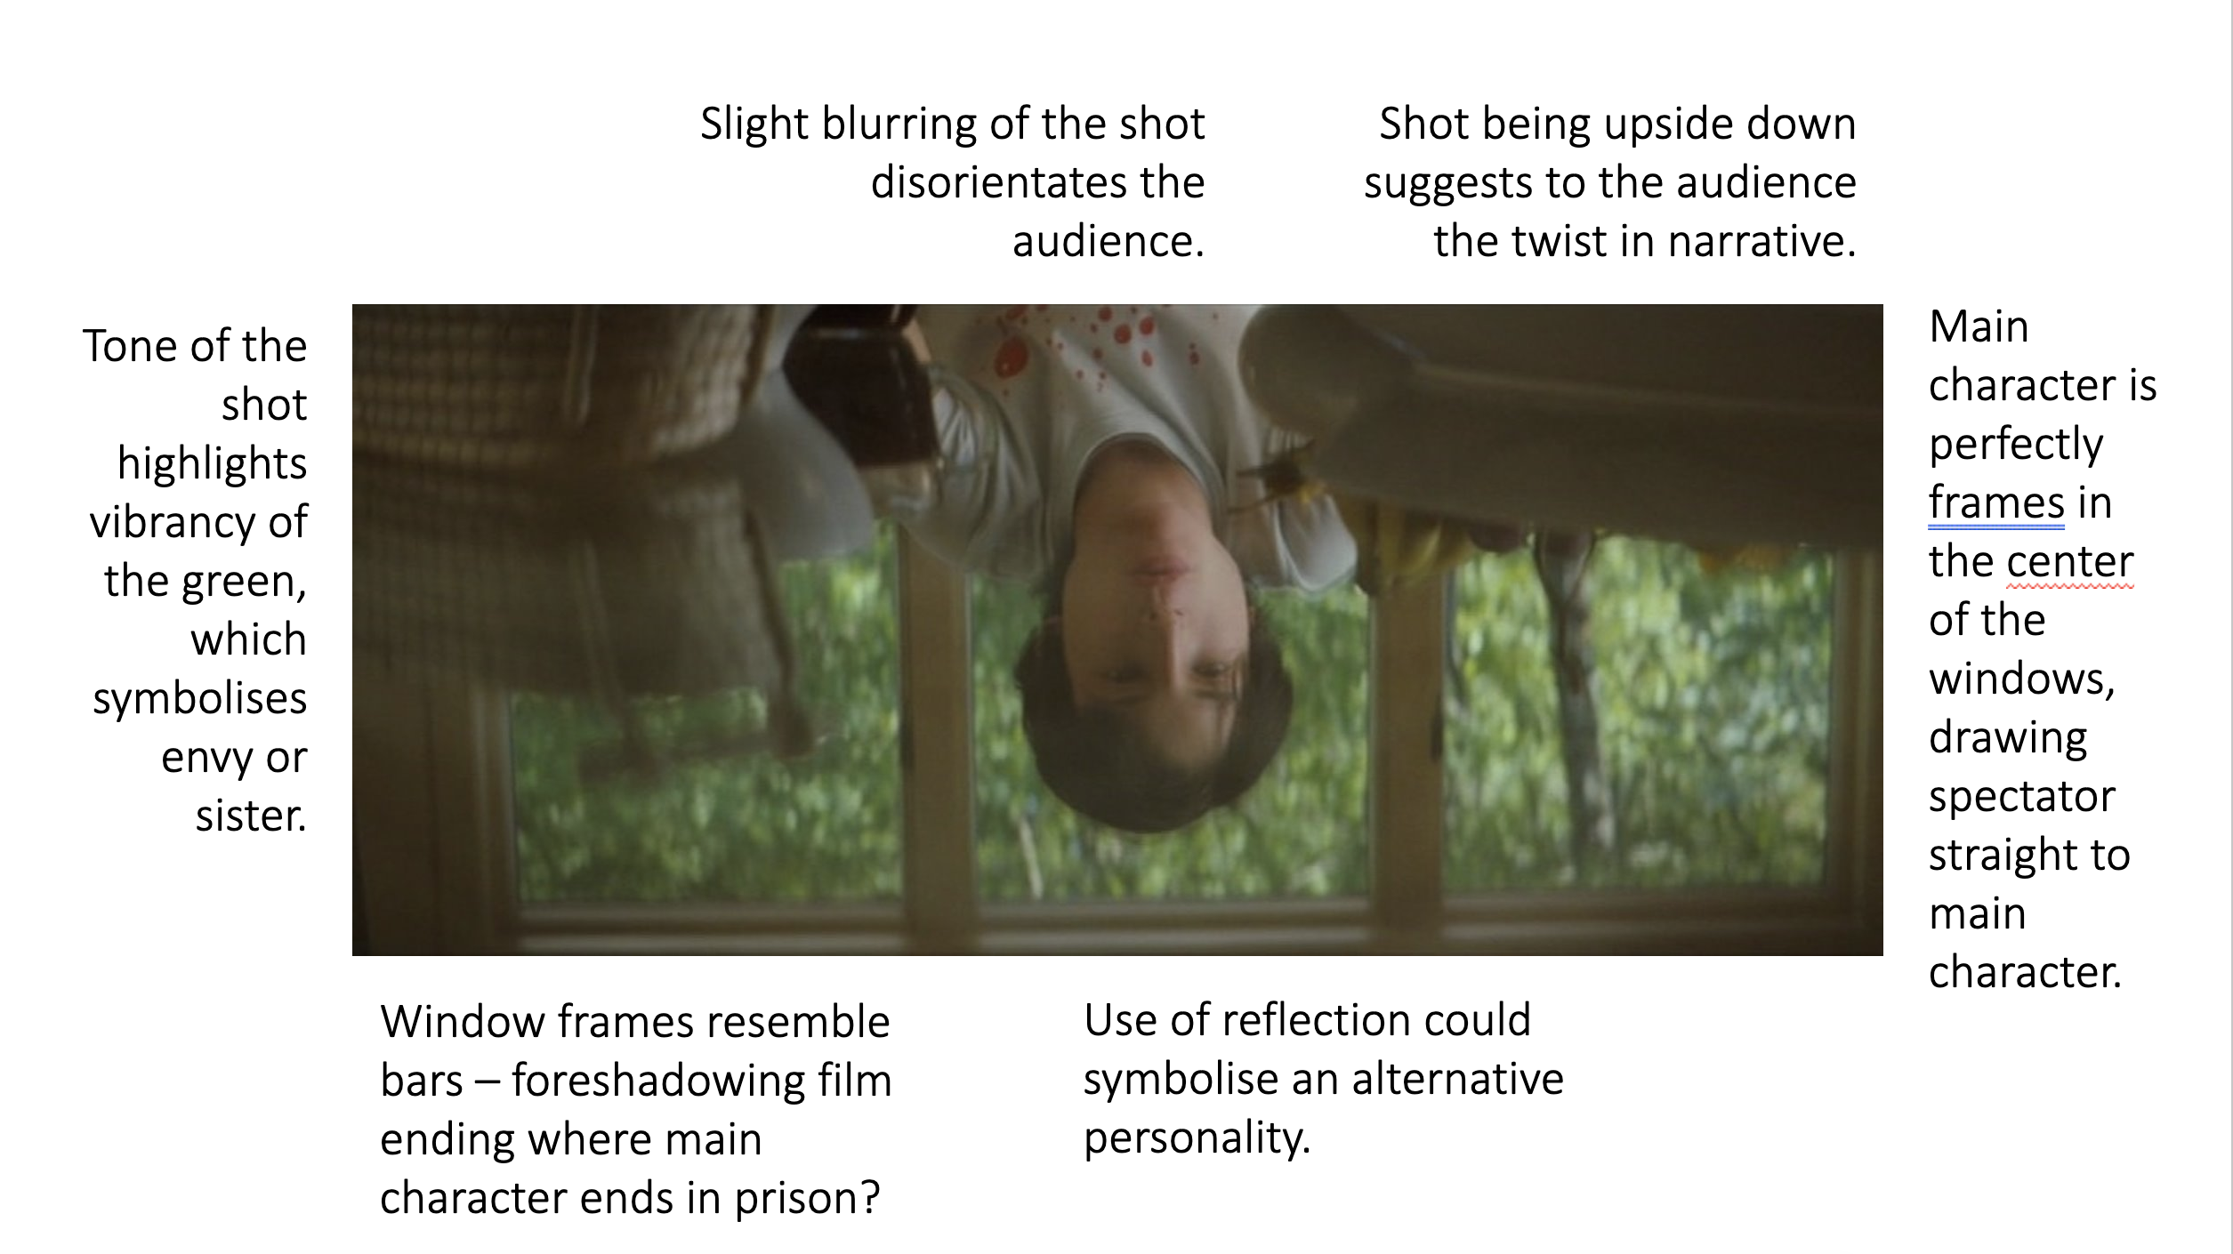
I can’t wait to see your results!
Nancy Catherall – Creative Media Tutor Nelson and Colne College

