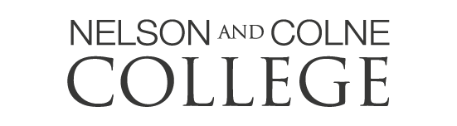
A Level Geology
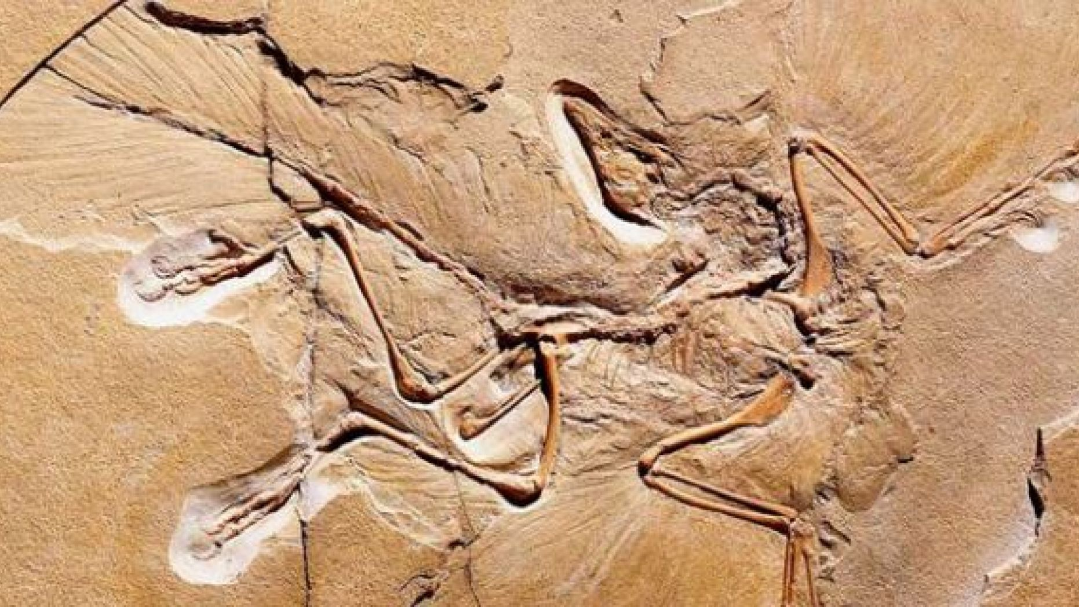
“Daily it is forced home on the mind of the geologist that nothing, not even the wind that blows, is so unstable as the level of the crust of this Earth.”
Charles Darwin (1832)

This guide has been designed to deepen your understanding of earth sciences before studying A-levels at Nelson and Colne College. It does not contain command words or exam questions…..
It does however contain a great list of resources to engage your brain and develop knowledge of the physical processes that shape our planet.

But I don’t know anything about geology!
Don’t worry…. anyone starting A-level Geology will not have studied it before either apart from some bits in geography. This guide has been designed for you to ‘dip your toe in’ to geology and start exploring some fundamental concepts.
The Geological Society
(https://www.geolsoc.org.uk/)
This is a ‘gold mine’ of information for any geologist whether you are a student or an expert. The following links may be of interest to a new student, although you can explore the whole website at your leisure.

Geology careers: A great poster (also displayed in our classroom) that shows all the different job sectors you can work in with an earth science degree.
https://www.geolsoc.org.uk/~/media/shared/documents/education%20and%20careers/Resources/Posters/Geoscience%20for%20the%20Future%20poster.pdf?la=en

Geology careers: Part of the website is specifically for finding out different job opportunities. This is an interactive page for you to explore different career areas in earth science.
https://www.geolsoc.org.uk/geologycareerpathways

Why A-level Geology? This page describes why you should choose A-level Geology
https://www.geolsoc.org.uk/~/media/shared/documents/education%20and%20careers/Schools/The%20Value%20of%20Geology%20A%20Level.pdf?la=en

Activity sheets. A variety of easy to digest resources on all kinds of topics from minerals to dinosaurs. High recommended.
https://www.geolsoc.org.uk/Education-and-Careers/Resources/Activity-Sheets-And-Presentations

Factsheets. A variety of fact sheets on lots of topics. They make nice posters.
https://www.geolsoc.org.uk/factsheets

The rock cycle. This is a fantastic ‘microsite’ but still part of the RGS. It is a resource that guides learners through the rock cycle. It’s easy to understand and would be a great preparation for A-levels.
https://www.geolsoc.org.uk/ks3/gsl/education/resources/rockcycle.html

Plate tectonics. Same as above this is a ‘microsite’ and guides the learner through the theory of plate tectonics. We visit this theory as part of the A-level course.
https://www.geolsoc.org.uk/Plate-Tectonics
British Geological Survey
(www.bgs.ac.uk)
This organisation has been at the forefront of geological mapping since 1835. Their website is full of loads of great information. Some of the following may be of interest.

Geological timeline. A nice interactive way of trying to get your head around how old the earth is. Mind-bending.
https://www.bgs.ac.uk/discoveringGeology/time/timeline/entertimeline.html?

Climate change. A nice section on their website is about climate change. It discusses longer climate variations as well as the current warming phase we are living in.
https://www.bgs.ac.uk/discoveringGeology/climateChange/home.html?src=topNav

Minecraft. I’m not familiar with Minecraft but if you are you can download the complete geology of the British Isles onto it. Enjoy!
https://www.bgs.ac.uk/discoveringGeology/geologyOfBritain/minecraft/home.html?src=topNav#/6232/64/22413/-11/0/0

Geohazards. Everything you want to know about hazards like earthquakes and volcanoes.
https://www.bgs.ac.uk/discoveringGeology/hazards/home.html?src=topNav

Geology the UK map. This is brilliant. It is an interactive map showing the geology of the UK. Try finding your house and seeing what its built on.
http://mapapps.bgs.ac.uk/geologyofbritain3d/

IRIS (Incorporated Research Institutions for Seismology)
www.iris.edu
You could quite easily spend a few hours exploring this website, containing everything you never knew you didn’t know about earthquakes! Start on the videos section…
https://www.iris.edu/hq/inclass/search#type=8/language=1

Other interesting websites
Geology.com. One from the USA. Lots of interesting info including geology in the news and information on a comprehensive range of subjects
https://geology.com/

Guardian newspaper. Follow this link to see any geology themed news stories in the papers at the moment.
https://www.theguardian.com/science/geology

USGS. This website from the USA has a nice online map to see the most recent earthquakes and where they have struck. Its updated minute by minute.
https://earthquake.usgs.gov/earthquakes/map/

Documentaries
There are some great geological documentaries which will help develop your general geographical knowledge and understanding and help you see what an amazing world we live in.

How the Earth Made Us - Prof. Ian Stewart originally on BBC2
How the Earth made us – BBC documentary – Episode 1
https://www.dailymotion.com/video/x7380h2
How the Earth made us – BBC documentary – Episode 2
https://www.dailymotion.com/video/x738d9i
How the Earth made us – BBC documentary – Episode 3
https://www.dailymotion.com/video/x77a1tm
How the Earth made us – BBC documentary – Episode 4
https://www.dailymotion.com/video/x77a5nu
How the Earth made us – BBC documentary – Episode 5
https://www.dailymotion.com/video/x76f0c2

Men of Rock. Professor Ian Stewart originally on BBC2.
A story of how early geologists discovered some important concepts that have shaped how we see our world.
Episode 1
https://www.youtube.com/watch?v=FYfuI2uZLmg
Episode 2
https://www.youtube.com/watch?v=w1wH3cGQLjE
Episode 3
https://www.youtube.com/watch?v=K7Ej2-mFsIQ

Films
Into the Inferno: With stunning views of eruptions and lava flows it captures the raw power of volcanoes. Currently on Netflix.

Journey to the centre of the earth: a film of the classic book by Jules Verne. There are some scientific inaccuracies!

San Andreas: an entertaining look at how scientifically inaccurate one film can be.

Books (A very small selection)
Evidence suggests that students who read for enjoyment not only perform better in tests than those who don’t, but also develop a broader vocabulary, increased general knowledge and a greater ability to learn new information in the future.

- Underland: A Deep Time Journey
Robert Mcfarlane

- The Story of Earth: The First 4.5 Billion Years, from Stardust to Living Planet

Robert M Hazen

- The Planet in a Pebble: A journey into Earth's deep history

Jan Zalasiewicz

- Vanished Ocean: How Tethys Reshaped the World Paperback

Dorrik Stow
Youtube videos
There is a lot of rubbish on YouTube…. But there is some good stuff too including the following links to give you a good first intro into geology by an American lecturer.

What are earth sciences?
https://www.youtube.com/user/mikesammartano
What are minerals?
https://www.youtube.com/watch?v=fnHgMLJq7VI
How to identify minerals.
https://www.youtube.com/watch?v=KB-2pO7pSK8

ONLINE COURSES
Learning is the best way to stay engaged with the world. Whether you’re looking for a new subject, are seeking out a new skill, or are hoping to get ahead of the curve with some preparation for A-level, there are hundreds of online courses available to you.

The Open University
https://www.open.edu/openlearn/science-maths-technology/science/geology
Loads of short and long free geology courses can be found here.

Future Learn – https://www.futurelearn.com/courses/geology
Future Learn is a convenient online hub for free online courses. They collate loads of courses from top UK and European universities. You can filter your course search by subject, the amount of time you’d like to spend studying a week, and the duration of your course. The link here takes you straight to the geology courses.

EdX courses
https://www.edx.org/learn/geology
edX is a trusted platform for education and learning based in the US. Founded by Harvard and MIT, edX is home to more than 20 million learners, the majority of top-ranked universities in the world and industry-leading companies.

Ivy League Online Courses
https://www.classcentral.com/collection/ivy-league-moocs
An incredible opportunity to study at an Ivy League University! Brown, Columbia, Cornell, Dartmouth, Harvard, Penn, Princeton, and Yale have made thousands of courses available for free. Search their catalogue for a course which links to one of your chosen A Levels or quite simply something which has always interested you! These courses are free, and you will receive a certificate of completion (at a small cost) upon completion. Another key feature for potential UCAS applications.

