Getting ready for college
Subject | Photography
Level | A-level
Qualification | A-level Photography
Exam board / awarding body | AQA
Getting ready to study
As part of the Photography project in the first year of your course you will be learning how to see and compose images to maximum effect. This is a vital tool to use each time you find something to photograph. This all takes practice and will improve over time. During your Photography classes you will learn about the essential elements and other ways to improve your compositional techniques.
A fun task that you could try is using your phone / camera to discover unusual compositions using the alphabet. See how many letters you can find around you. This will make you look more and discover areas and ways to photograph which you may never have thought of. See the images below to give you inspiration for this. You never know you may be able to create a full alphabet!
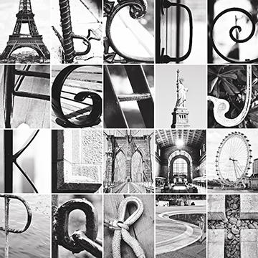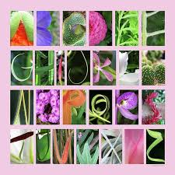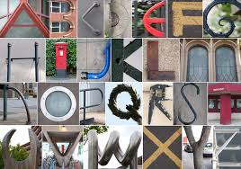

Sharon Scaturro – A Level Photography Tutor Nelson and Colne College.

