Getting ready for college
Subject | Programming
Level | LEVEL 3
Qualification | Extended Diploma in IT/Digital T-level
Exam board / awarding body | BTEC Pearson
Getting ready to study IT
As part of the L3 IT program you will be developing programming skills. Programming is a transferrable skill and highly sought after by employers. People with programming skills are more likely to gain university offers and job offers. It does not matter what programming language you study because the foundations are similar, and you can use the same principles in different languages.
One of the programming languages you will be learning is python. Some of you may have already studied this at school or independently, which is fantastic. To help you build the skills needed for the Level 3 course in IT or the Digital T-level course I highly recommend that you sign-up for this free online python tutorial course. The course will take you through the basics of python programming from a beginner level and introduce you to the fundamentals of the language. In the tutorial they will also show you how to download the software.
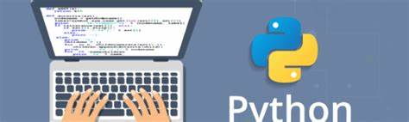
You will need to click on the link below which will take you to the website and then you can enrol onto the course. Other courses are also available for you to browse.
https://www.udemy.com/course/python-fundamental-basics/

Nafisa Naheed
Creative and Digital Curriculum Leader

