Getting ready for college
Subject | Programming
Level | LEVEL 3
Qualification | Extended Diploma in IT/Digital T-level
Exam board / awarding body | BTEC Pearson

Python Task Year 11 Event
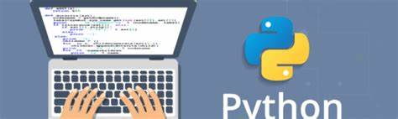
On google chrome browser enter repl.it
At the bottom of the website you will find various programming languages. Select Python. You will see something like the image below. The white area is where you enter the syntax (code). The black screen is where you will find the result.

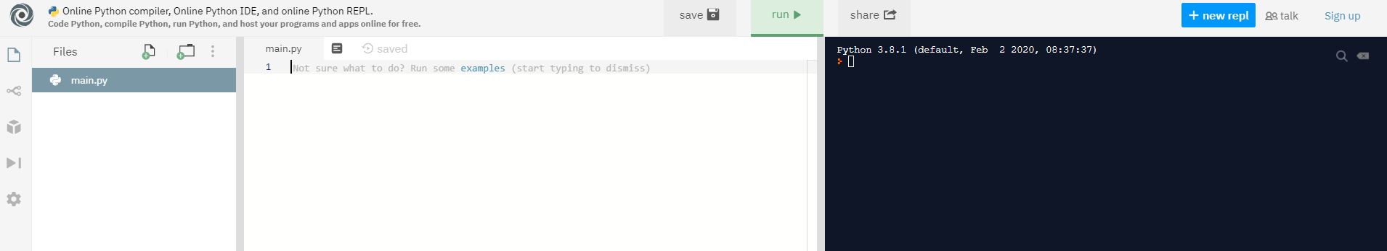

Enter the following and press run

print(“my name is Haroon”)
The print must be in small case and it is a keyword in Python.

Variables

Variables are like storage boxes in programming. You can put various items within the storage boxes. We will look at two types of storage boxes. String and Integer.

String is words
Integer is numbers.
Delete the previous print statement and enter the following:
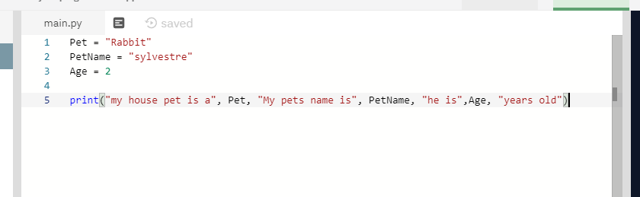

Task
Now declare three variables of your own. This time use two integers (numbers) and one String (words).

Internet research task

Using the internet, I would like you to find what command you use to ask the user to enter their name (user input), then print out welcome and their name.

Answer

