Getting ready for college
Subject | Textiles
Level | Level 3
Qualification | A Level
Exam board / awarding body | AQA
Getting ready to study
In the first year of your A Level Textiles course you will be learning a lot of new techniques and processes like machine and hand embroidery, screen printing, tie dye, felting and so much more.
Even if you think you can’t do these, you will be taught how to do them and gain a real skill in them so that you can gain a high grade in your A Level in year 2. It is all about practice, about making lots of mistakes but also about moving forward and making improvements each time you experiment with a process.
I will always demonstrate what we will do in class then support you to make fashion or textiles pieces.
At the moment in the media there is a lot about fast & slow fashion, recycling and upcycling.
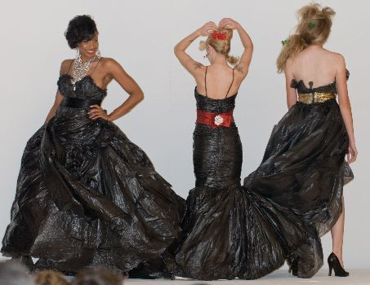
I want you to do some research into this, so you are aware of these issues. Make notes so you don’t forget what information you have found out about it and we will do some work in class about it when you start.
When you have done that, I want you to find a garment or garments that either you or someone in your house doesn’t wear anymore and upcycle it for a celebrity that you admire. Use Pinterest and google to research for ideas by putting in ‘upcycled garments and fashion designers that use upcycling’. You all have different tastes, so let your style and imagination take you in the direction you want to go.
Good luck and I can’t wait to see what you bring to show me in September.
Simone French Textile tutor.

Cerise Ward – Fine Art Tutor Nelson and Colne College

