Introduction au français au niveau A-Level.

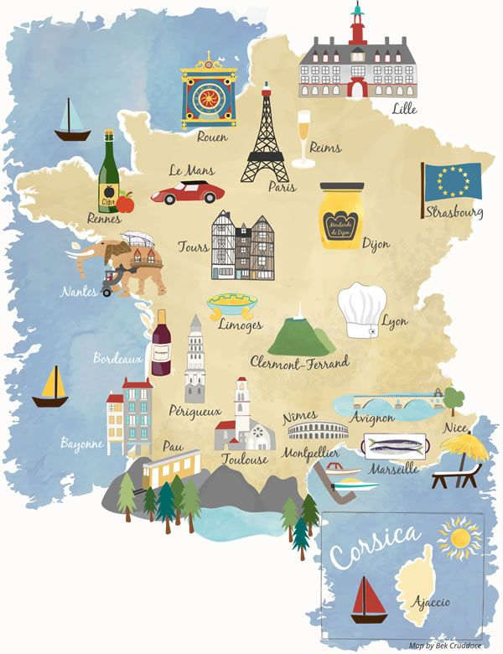

Travail d’été

Welcome to A Level French!

Up to GCSE level, French (like all MFL) is a skill-based subject. This means that rather than content, you have been learning how to understand written and spoken French, and how to communicate in written and spoken French. At A Level, you are using these skills you have acquired during GCSE to explore Francophone cultures.
In order to prepare efficiently for the A Level requirements, you should regularly expose yourself to the French language so you keep up your skills.
To prepare efficiently for September, you need tackle French reading and listening every week as well as consolidate your knowledge of grammar. But you also need to have some fun.
This workbook contains one section on each of these four aspects.
Try and complete at least one activity of each category per week during the summer holiday
You will find it is taking you a step up from GCSE so do take it easy and don’t panic if you do not understand everything as it is normal at this very early stage. Focus on grasping the gist rather than all the detail. Week after week you should find this becomes easier.

JOYEUSES VACANCES ET A SEPTEMBRE !

John Ranson
ransonj@nelson.ac.uk

INDEX

1. DEVELOP YOUR LISTENING SKILLS…………………………………………………………………….PAGE 3

2. DEVELOP YOUR READING SKILLS……………………………………………………………………..PAGE 5

3. REVISE AND ENHANCE YOUR KNOWLEDGE OF GRAMMAR……………………………….PAGE 7

4. HAVING FUN IN FRENCH! ………….…………………………………………………………………….PAGE 10

How to prepare for French at A Level 1: Develop your Listening skills

Watch

TELEVISION
- http://www.tv5monde.com/ Watch this channel to gain access to the last episodes of all of their TV shows. Check out their French language learning section at http://apprendre.tv5monde.com/ where you can watch clips and answer comprehension questions on what you have seen with accompanying grammar exercises.
- Download an app called 6play on your iPad – search in the App Store for M6. This is a popular French TV channel. Not all programmes are available outside of France, but there is a good selection and these help with listening skills.

LISTEN TO THE RADIO
The great thing about listening to the radio is that you can get on with something else at the same time. Listen live using the Radio France or the Europe 1. It sometimes takes a while to buffer so be patient.

- Radio France (www.radiofrance.fr)
- Europe 1 (www.europe1.fr)
- Le mouv (www.mouv.fr) (this is the French equivalent to Kiss FM or Capital)
- Europe 2 (www.europe2.fr)

WEBCASTS AND PODCASTS
Pick one of these suggested videos/podcasts below and listen to it several times, with subtitles first (if you have any) then without, pausing it often to try and digest the gist. You will not understand every single word and that is normal.
Then try to write a short summary (50-70 words) of the article. Summarising is a new skill at A Level so it would be useful to start getting your head around it. Write the summaries in your simple GCSE vocabulary so it is written in your own words rather than copied from the articles.
These websites provide challenging but manageable videos or podcasts in French about relevant topics:

Ilini – has the option of displaying French/English subtitles and clicking on a word to have its translation
Coronavirus
Patrimoine
Criminels
Sport

1jour1actu – simple vocabulary, all sorts of topics related to current events
Bénévolat
Technologie
Politique
Cinéma

Brut – more complex and some longer videos but usually with French subtitles to support you
Immigration
Diversité
Musique
Cinéma

How to prepare for French at A Level 2: Develop your Reading skills

Read

Keep your own vocabulary book for new expressions you come across. You could order it alphabetically, by topic area based on what we are going to study or just use it as a diary and scribble away your French development in it.

NEWSPAPERS AND MAGAZINES
Read a foreign language newspaper – Le Figaro is probably the best. Le Figaro has its own website http://www.lefigaro.fr/ so that you can read the paper online. You do not have to read the paper cover to cover, just scan the headlines and pick out ONE article that grabs your attention.

This website gives you access to newspapers all over the world. Here is the link to a range of French papers. http://www.mediatico.com/en/newspapers/europe/france/national/

This website is a more light-hearted newspaper which covers global stories as well as gossip. http://www.20minutes.fr. Also try http://www.20minutos.fr/tv/ . This is the TV Channel for this newspaper.

To catch up on the latest gossip and to see what the celebs are wearing, take a look at www.elle.fr.

Websites
1jour1actu provides brilliant resources for both reading and listening. Pick one of these suggested articles and read it through trying to understand the gist. You will not understand every single word and that is normal.
When there is one you can complete the interactive quiz at the end to check your understanding. Then try to write a short summary (50-70 words) of the article. Summarising is a new skill at A Level so it would be useful to start getting your head around it. Write the summaries in your simple GCSE vocabulary so it is written in your own words rather than copied from the articles.
Famille
Technologie
Bénévolat
Patrimoine
Musique
Cinéma

The day provides excellent translations of English articles in French. Pick one of these suggested articles and read it through trying to understand the gist (some useful vocab is provided at the end).
Then try to translate a passage into English and check your work by clicking the “simplified English version” option at the top.

Coronavirus
Technologie
Patrimoine
Terrorisme
Politique
Cinéma

Switch to French browsers such as and http://fr.yahoo.com/ or www.yahoo.fr as well as www.google.fr. This way, you will read French every time you log on and it will become part of your everyday activity.

Look at the BBC website http://www.bbc.co.uk/languages/french/tv for links to French programmes available on line.

Language skills: this website is free after 4pm and really comes into its own with its A level section. Watch news video clips, find theme related vocabulary and do listening and reading comprehensions. Find it here http://zut.languageskills.co.uk/advanced/year12.html

On-line dictionary
A good on-line dictionary is: http://www.wordreference.com/

TIP: When you are reading articles etc, try not to look up every word as it will take you forever. Skim and scan the text to get the gist. Remember to use the context or the article, cognates and common sense to figure out what the article is saying. Pick out a couple of words that you like the look of, that you feel may be real hurdles to getting the idea of the text, look them up carefully and add them to your vocab booklet. The aim at this stage is to get the gist of the article, not be able to translate it completely. Translation is a whole different ball game and you will learn it soon enough.

You will be surprised how much more enjoyable reading will be if you really pay attention to this tip.

How to prepare for French at A Level 3 : Revise and Enhance your knowledge of grammar

1. Links to Grammar Practice Exercises

- Languages on line: The Grammar Revision resources on
www.languagesonline.org.uk are great as you can then select what tense you want to revise, read the explanations and complete the exercises. You can do these as often as you like and it gives you a percentage. Another useful tactic is to translate the examples and exercises into English to ensure you understand the meaning of each tense.

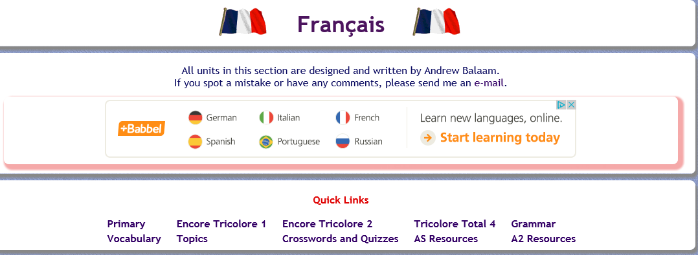
Either choose to practice your grammar or work through some of the AS Resources.

• Conjuguemos: a great website for practicing your verb conjugations. Find it here: https://conjuguemos.com/

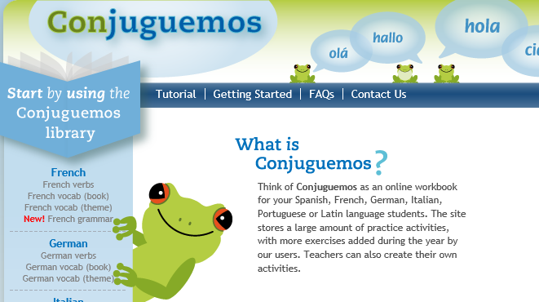
Click here to access the French verb exercises.

• Language skills: this website is free after 4pm and really comes into its own with its A level section. Practice your verbs, pronouns, do practice translations and review other grammar points. Find it here http://zut.languageskills.co.uk/advanced/year12.html.

2. Grammar. What should I know by now?
To find out, go through this self-assessment checklist of the grammar for GCSE French:

 |  | I DO NOT KNOW | NEED TO LEARN | QUITE CONFIDENT | FULLY  CONFIDENT
 | Nouns: gender, singular and plural forms
 | Articles: definite (le, la...), indefinite (un, une)
 | Partitive (de, du...)
 | Adjectives: agreements (fem, pl...)
 | Position/word order
 | comparative and superlative (plus, la plus..)
 | comparative and superlative irregular (mieux...)
 | demonstrative (ce, cet, cette, ces)
 | indefinite (chaque, quelque)
 | possessive (mon, ta...)
 | interrogative (quel, quelle...)
 | Adverbs: comparative and superlative
 | interrogative (comment, quand)
 | Quantifiers/intensifiers (très, assez...)
 | Pronouns: Subject (je, tu...)
 | object: direct and indirect (le, lui...)
 | position and order (je la lui donne)
 | reflexive (me, te...)
 | relative (qui, que,)
 | object: direct and indirect
 | disjunctive/emphatic (moi...)
 | indefinite (quelqu’un)
 | possessive (le mien...) (R)
 | interrogative (qui, que)
 | use of y, en (+ word order)
 | Verbs: modes of address (tu, vous)
 | Impersonnel verbes (il pleut / il faut...)
 | verbs + infinitive
 | verbs + infinitive + preposition
 | Verbs + à (je m’intéresse à)
 | Verbs + de (je viens de)
 | negatives (ne..plus, pas...)
 | Interrogative [question] forms (avez-vous...)
 | Present (regular)
 | Present (irregular)
 | Perfect with avoir
 | Perfect with être
 | Perfect with reflexives
 | Imperfect
 | Future

 |  | NOT KNOW | NEED TO LEARN | QUITE CONFIDENT | FULLY  CONFIDENT
 | Conditional
 | Pluperfect (j’avais eu...)
 | Indirect speech
 | Inversion after speech
 | Prepositions: à, au...
 | with countries, towns, places
 | with month, dates, time
 | depuis, venir de
 | Number, quantity and time
 | Conjunctions (pour, aussitôt que etc.)

How did you get on?
If you need further practice, work through the grammar pages of whichever GCSE textbook you are used to.
However, for a more interactive and thorough practice, please pick one of these suggested websites and work on at least one tense and one other language point per week.
BBC Bitesize
Tex’s French Grammar
REFERENCES: Internet

www.languagesonline.org.uk www.s-cool.co.uk/a-level/french http://french.about.com www.verb2verbe.com www.alevelfrench.com www.frenchexams.org www.lepointdufle.net www.bbc.co.uk/languages/french

Reference books

Élan grammar workbook
Easy learning French grammar Practice in French grammar
Help yourself to French grammar

general site with an A Level section & GCSE revision (grammar very good) good site with lots of materials & downloads (need to register but free)
a really good general site for grammar
site which translates any verb in any form (F>E & E>F) click on: move up to A Level transition
interactive revision materials
a very comprehensive search engine for French grammar interesting site especially the French slang section

Oxford Collins
Nelson Thomas Longman

How to prepare for French at A Level 4: Having Fun in French

Above all though, French, needs to be FUN! The following pages should help you find that fun for yourself!

NETFLIX - Top French films + TV series to watch

- Bad Seeds (Comedy, rated 15)
- The Climb (Comedy, rated 15)
- We Are Family (Comedy, rated MATURE)
- Divines (Drama, rated 15)
- Paris is Us (Romantic film, rated 12)
- Twice Upon a Time (Romantic TV drama, rated 15)
- Ares (Action & Adventure, rated MATURE)
* Make sure you put audio in original French with English subtitles
You tube links for French learners
Music - If you like a track, search for the karaoke version – many exist!

Easy French interviews about French pop music https://www.youtube.com/watch?v=xce94Wvytgo

LEJ – female group https://www.youtube.com/watch?v=diOZna03YMo
https://www.youtube.com/watch?v=B9pF9kqWNJ4

Grand Corps Malade – poetic Parisien slam rap
https://www.youtube.com/watch?v=RcxRMikZrbY

Indila – female vocalist
https://www.youtube.com/watch?v=ZthUo-Z97uw
https://www.youtube.com/watch?v=sI8vLseTYs8- bilingual lyrics
https://www.youtube.com/watch?v=VvjD-OBtg3U
https://www.youtube.com/watch?v=ImI1TghBZNM

Angèle – New wave French pop female composer and vocalist
https://www.youtube.com/watch?v=W8t1yymfqRI Oui ou non
https://www.youtube.com/watch?v=EHxT1JKLYes tout oublier
https://www.youtube.com/watch?v=FdkgDZg19jc Duo with Philippe Katerine

Roméo Elvis – brother of Angèle- cheeky Belgian rapper!
https://www.youtube.com/watch?v=JmIPRfMhzlM soleil

Suzane – conscious electropop
https://www.youtube.com/channel/UCY0I0w7JbRyn-5p5Ni9Z9_A

Zaho – female vocalist
https://www.youtube.com/watch?v=89TdUMfYhzQ

Stromae – the daddy of Euro Dance music French style!

https://www.youtube.com/watch?v=LhddrZJ98SI
https://www.youtube.com/watch?v=37StRy0LEbI feat Orelsan

Big flo et oli
Feat Squeezy https://www.youtube.com/watch?v=0S-0jhWMYMc&list=RDEMC0-ZAoKC21J63CqqVfdcng&index=2
https://www.youtube.com/watch?v=wRFb5M2o6-k

Coeur de pirate – Canadien female vocalist
https://www.youtube.com/watch?v=012QM1nSImU

Louane – star of the film La famille Belier
https://www.youtube.com/watch?v=TbKyQWaY1So

Vitaa et Slimane – love ballads
https://www.youtube.com/watch?v=mdg1fFSAoEw

General site with over 50 songs in French and English - some classics, some pop, some a little different!
https://www.youtube.com/channel/UCLOGvUn51HA7iVgUL2yFS6g/videos

Bon entendeur Background poppy stuff
https://www.youtube.com/watch?v=bKUMaibnQKU

French reggae
Masillia Sound System – from Marseille
https://www.youtube.com/watch?v=CRX835B6Gxs

Khalifa –Monsieur Addy’s Childhood friend from Normandy
https://www.youtube.com/watch?v=81CxL8OaE74&list=OLAK5uy_lSN8OlQ75gr9xNX3RkUg-uQ7VEtbUPsIw&index=2
Quitte-moi
https://youtu.be/mfh5jxuI2sY - I wanna Know

Cartoons

Peppa Pig
https://www.youtube.com/watch?v=--N-tHiq_Co

Tchoupi
https://www.youtube.com/watch?v=bTxFrk02CmY&list=PLvlBJX9yXVggEIOXVOqRG1Sux5AdiSHi6

Caillou
https://www.youtube.com/watch?v=Kp1cgcSALLg

Trotro
https://www.youtube.com/watch?v=XIZ2gLCkv5Y

French Music – Weekly Playlists
To help keep you entertained, each week, listen to a playlist of eight French songs to listen to. Listen to as many songs you can and make a note of any songs you particularly enjoyed.
TAKE IT FURTHER:
To improve your listening skills and learn about French culture, take it further by listening to a French song and complete the activities:
- Translate the song title into English eg 'La Thune' by Angèle
- Listen to the song 2-3 times and note down at least 5 French words that you recognise. Translate them into English.
- Read the lyrics to check if you were right and to check your spelling.
- Write a sentence in French to give your opinion of the song (i.e. Did you like the song? Why? What did you think of the video?) and email it to your teacher. Include as much quality and complex language as you can!
Some Useful phrases…
Ma chanson préférée est … > My favourite song is …
la chanson qui s’appelle … de … > the song which is called … by …
Ça me plaît car/parce que… > I like it because ….
j’aime bien la vidéo > I really like the video
ça me donne envie de danser/chanter > it makes me want to dance/sing
Playlist 1
1) Bigflo & Oli Demain https://www.youtube.com/watch?v=d-VE9Kba3GY
2) Louane Avenir https://www.youtube.com/watch?v=niyGWxVE-e4
3) Ben l’Oncle Soul Soulman https://www.youtube.com/watch?v=69ptYXvUo7M
4) Soprano Zoum https://www.youtube.com/watch?v=jQgrOe93kRQ
5) 47Ter Côte ouest https://www.youtube.com/watch?v=nPwGvjd2zOU
6) Black M Mon beau-frère https://www.youtube.com/watch?v=N6nZ8B2rtdU
7) Olivier Dion Si j’étais son soleil https://www.youtube.com/watch?v=kSH__16jbDU
8) Boulevard des airs Allez reste https://www.youtube.com/watch?v=lM3R1vkb21s
Playlist 2
1) L.E.J Liberté, égalité https://www.youtube.com/watch?v=3CSyUALR31E
2) Gavin James Always https://www.youtube.com/watch?v=sTHlIdqXSL0
ft. Philippine
3) Calogero Je joue de la musique https://www.youtube.com/watch?v=SPK9fxvvbfk
4) OrelSan Rêves bizarres https://www.youtube.com/watch?v=iXzBdNjpYw0
5) Angelina Maman me dit https://www.youtube.com/watch?v=7BOtRTM_Y7I
6) Stromae Formidable https://www.youtube.com/watch?v=S_xH7noaqTA
7) Arcadian Petit à petit https://www.youtube.com/watch?v=-ow0ODm_tG0
8) Erza Muqoli Je chanterai https://www.youtube.com/watch?v=EiAej_sSpbI
Playlist 3
1) Camélia Jordana Dans la peau https://www.youtube.com/watch?v=J1rJiQ0B5eY
2) Madame Monsieur Les lois de l’attraction https://www.youtube.com/watch?v=6eiYgGDMp1Q
3) Shy’m L’Effet de serre https://www.youtube.com/watch?v=EH305KFp5mA
4) Toofan (ft Louane) La vie là-bas https://www.youtube.com/watch?v=jG1A0Cy3qYo
5) Georgio Miroir https://www.youtube.com/watch?v=GKrG4_3Q1FY
6) Disiz la peste Ça va aller https://www.youtube.com/watch?v=waddvefgkBw
7) Christophe Maé Les gens https://www.youtube.com/watch?v=qJ5GiJYfOfg
8) Tryo L’hymne de nos campagnes https://www.youtube.com/watch?v=u5WPt7cBpfg
Playlist 4
1) Kids United Mama Africa https://www.youtube.com/watch?v=Nn1Zs_ijOZA
2) Aöme Seul à seul https://www.youtube.com/watch?v=AMeGhmrRh9E
3) Christine & the Queens La marcheuse https://www.youtube.com/watch?v=CneMUoqpebo
4) Marie-Mai Élever https://www.youtube.com/watch?v=1Hgx2QBhU_I
5) Maître Gims La même https://www.youtube.com/watch?v=fC6YV65JJ6g
(ft Vianney)
6) Hervé La peur des mots https://www.youtube.com/watch?v=qbprFhA1b8U
7) Dadju Compliqué https://www.youtube.com/watch?v=bFEP26jCtsQ
8) Léonie Voulez-vous https://www.youtube.com/watch?v=SASWnVYToKE

Playlist 5
1) M Pokora Tombé https://www.youtube.com/watch?v=HX5l5DxmmBw
2) Marwa Loud Fallait pas https://www.youtube.com/watch?v=5UV1aEkBgAk
3) Magic System Magic in the air https://www.youtube.com/watch?v=BAkqJT_sMKQ
4) Les Trois Accords Bactérie #1 https://www.youtube.com/watch?v=xSj2kl_adk8
5) Angèle La thune https://www.youtube.com/watch?v=m3YX8zlR4BU
6) Coeur de Pirate Ne m’appelle pas https://www.youtube.com/watch?v=g__iNTJ19cs
7) L.E.J. Summer 2016 https://www.youtube.com/watch?v=OYDNfujwD1Y
8) Philippine C’est beau, c’est toi https://www.youtube.com/watch?v=82kJAYGEgX0

