Hello,
My name is Przemek and I will be teaching you this year on Law, Justice and Protective services.
Most of you would like to work as police officers. To be one, you need to be healthy and fit.
That is why I designed a few tasks for you around dieting and lifestyle.
Have a look below and do as much as you can.

Enjoy.

Task 1
Our bodies need fuel. In order to be healthy and fit, we all need to eat and drink. Our food consists of basic nutrients without which we cannot survive.
Below is the list of the nutrients we need to consume. Please explain in a few words what they are needed for and the best source of that nutrient.
For example, eggs and fish are great sources of protein and protein is needed to… (I’ll leave that for you to figure out)
Nuts are full of healthy fats

Carbohydrates-

Protein-

Fats-

Water (the source is rather obvious)-

Vitamins-

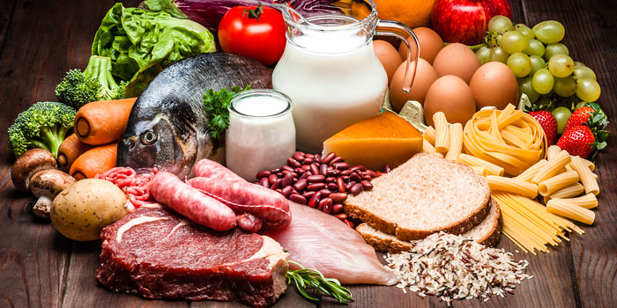
Task 2
There are many diets that you might have heard of i.e. Paleo, Keto, 6-18, 5-2, kosher or halal.
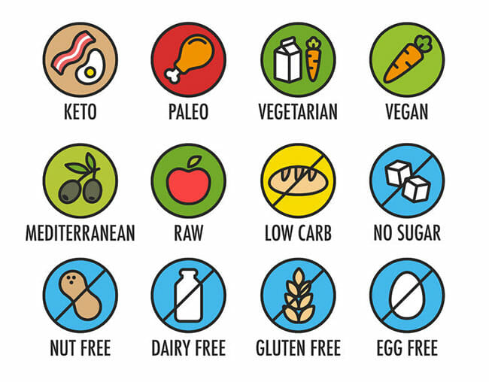
I have chosen 4 for you to do a research about and tell me what they are about. Please explain what the diets are about i.e. what you are/are not allowed to eat, what quantities, what time etc. Be as specific as you can. Who knows - you might like one and try it.

- Keto/Ketogenic diet:

- Kosher diet:

- Vegan diet:

- 16:8 diet:
Task 3
Your lifestyle can have a significant effect on your health. The way you live your life and the choices you make can lead to good health and fitness or poor health and fitness. Career in police force will require from you to be fit and in a good health.
Explain, in the table below, what negative effects poor lifestyle choices can have on your health and life.
Lifestyle choice | Effects on your body
Lack of exercise
Smoking
Not enough sleep (staying up late and waking up early)
Poor personal hygiene (not having a bath or shower regularly, not wearing clean clothes etc.)
Alcohol misuse
Drug misuse

