Getting ready for chemistry at college
Subject | Chemistry
Level | A-level
Qualification | A-level Chemistry
Exam board / awarding body | OCR Specification A

Dear A-level Chemistry applicant,
This pack contains a programme of useful activities and resources to prepare you for an excellent start to A-level Chemistry in September. You should aim to complete it in this summer term and over the Summer Holidays to ensure you are ready to start your course.
We look forward to meeting you in September.

Gary Goldsmith, Michelle Buchannan, Becci Bibby
(A-level Chemistry team)

Things you need to bring in September for your A-level Chemistry course:
- A ring binder folder and dividers to sort organize and keep your work.
- Standard writing equipment, including: pens, pencils, ruler/s and a scientific calculator.

Reading
The two links below are useful books to consider if you wish:
Key math’s skills in A-level Chemistry:
https://www.cgpbooks.co.uk/secondary-books/as-and-a-level/science/chemistry/cmr71-a-level-chemistry-essential-maths-skills
Below is a link to a free eBook version of a Head Start in Chemistry. This is usually around £4.95 in the shops.
https://www.amazon.co.uk/Head-Start-level-Chemistry-Level-ebook/dp/B00VE2NIGG/ref=pd_vtp_351_1/260-6001683-7946505?_encoding=UTF8&pd_rd_i=B00VE2NIGG&pd_rd_r=a1a53c23-59b9-466b-bb50-502da3c65f7c&pd_rd_w=4yrgN&pd_rd_wg=hbriz&pf_rd_p=4915ec70-d6be-4f9c-9f8d-52e90bdd07c5&pf_rd_r=PD5PWAHQD16BBKRNFHTE&psc=1&refRID=PD5PWAHQD16BBKRNFHTE
You will also find your GCSE books useful to recap some key topics which will appear in your A-level Chemistry program.
You should look at the OCR Chemistry specification before starting the course:
https://www.ocr.org.uk/Images/171720-specification-accredited-a-level-gce-chemistry-a-h432.pdf

Watch:
Follow the link below if you prefer watching videos to recap some of your GCSE Chemistry!
https://www.youtube.com/channel/UCqbOeHaAUXw9Il7sBVG3_bw/videos

Online learning revision activities.
Some of these links take you to online games / puzzles others to some written questions and activities
Topic | Some useful Links to online activities
Multiple topics:  The following will be useful with this link:  - Acids  - Alkalis  - Alcohols  - Alkanes  - Allotropes of carbon  - Atomic structure  - Everyday chemicals  - Ionic formula 1 & 2  - Mole equations  - Multiples of units  - State symbols  - Subatomic particles  - Tests for anions  - Types of bonding  - Units of volume | http://www.rsc.org/learn-chemistry/resources/gridlocks/level-2.html  (Puzzle online games based on moles equations & units, acids & bases, bonding, atomic structure).  These should help you recap some of your GCSE knowledge.
Basic practical competencies | https://edu.rsc.org/resources/basic-practical-competencies-starters-16andndash18/4010260.article
Basic essential Chemistry skills | https://edu.rsc.org/resources/basic-chemistry-competencies-starters-16andndash18/4010256.article
Key math’s skills for chemists | https://edu.rsc.org/resources/basic-mathematical-competencies-starters-16andndash18/4010259.article
Atomic structure | https://phet.colorado.edu/en/simulation/build-an-atom Atomic structure revision simulation
Online Titration screen experiment. There are multiple difficulty levels to try! | http://www.rsc.org/learn-chemistry/resources/screen-experiment/titration/experiment/2
Equilibria:  Download the attached document and complete the quick 10 mark quizzes.  Answers are at the back of the document. | https://edu.rsc.org/resources/equilibria-starters-1-16andndash18/4010277.article
Interactive physical chemistry simulations | https://edu.rsc.org/resources/collections/phet-interactive-simulations
You tube link to recap bonding. | https://www.youtube.com/user/virtualschooluk/search?query=bonding

Questions to answer:
You should further prepare for A-level Chemistry by practicing some GCSE exam questions. A link to some exam board websites can be found below. You should look at the Higher tier papers!
AQA: https://www.aqa.org.uk/subjects/science/gcse/chemistry-8462/assessment-resources?f.Resource+type%7C6=Question+papers&sort=date&num_ranks=20&start_rank=1
OCR: https://www.ocr.org.uk/qualifications/gcse/gateway-science-suite-chemistry-a-j248-from-2016/assessment/

Below are some exam questions to practice and a quick alkane and alkene summary task:

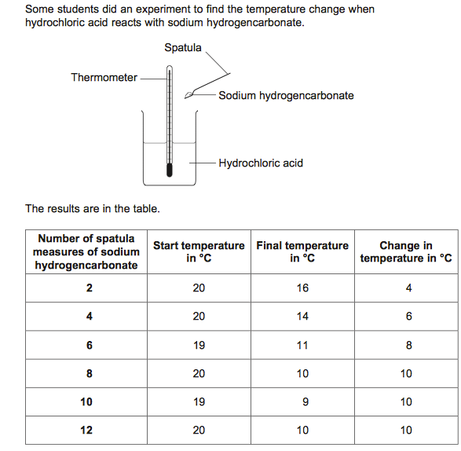

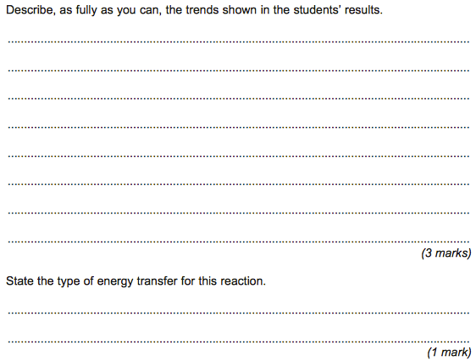

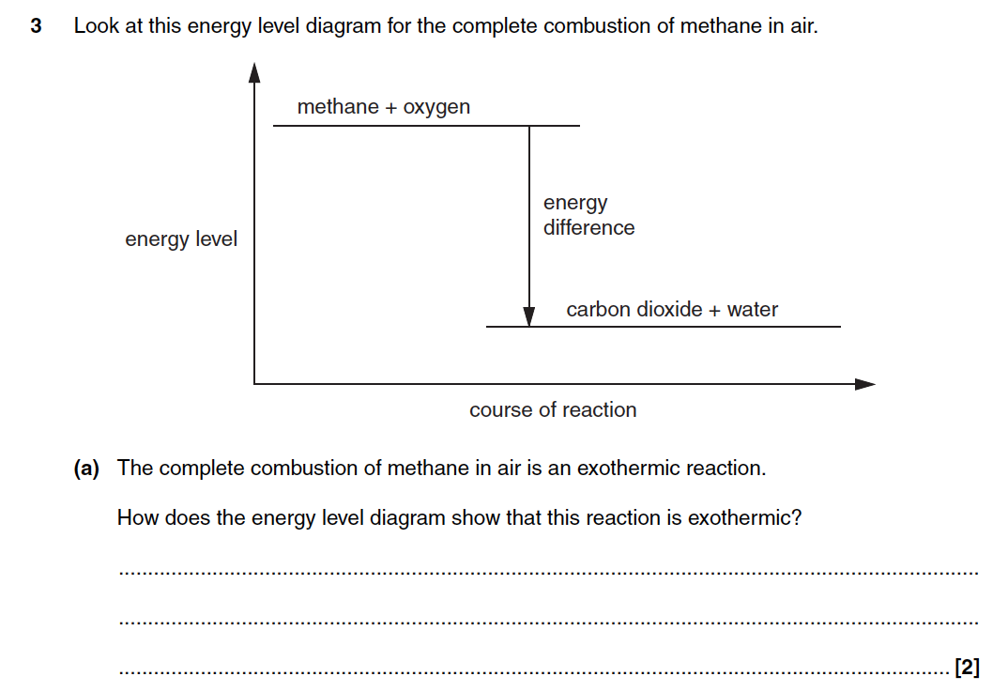

Q1. In 1909 Fritz Haber invented a process to produce ammonia from nitrogen and hydrogen.
(a) Complete and balance the chemical equation for the production of ammonia from nitrogen and hydrogen.
N₂ + 3 H₂ ....................
(2)

(b) The figure below shows how the equilibrium yield of ammonia changes with pressure at different temperatures.
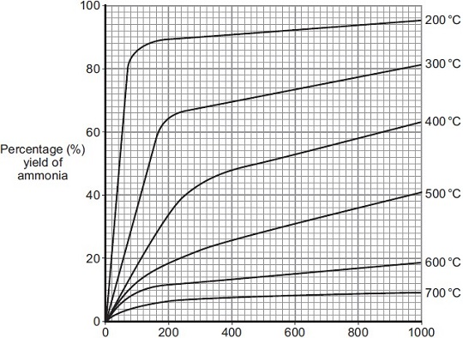
Pressure in atmospheres
(i) Use the information in given in the figure to complete the sentence.
The temperature on the graph that gives the highest yield of ammonia is ................. °C.
(1)

(ii) The temperature used in the Haber process for the production of ammonia is 450 °C.
Why is a temperature much lower than 450 °C not used for the Haber process?
...............................................................................................................
...............................................................................................................
(1)

(iii) Use the information in the figure to answer this question.
Draw a ring around the pressure that gives the highest yield of ammonia.

 | 100 | 200 | 300 | 400

(1)

(iv) The pressure used in the Haber process for the production of ammonia is 200 atmospheres.
Why is a pressure lower than 200 atmospheres not used for the Haber process?
...............................................................................................................
...............................................................................................................
(1)

(Total 8 marks)

Q2.A company manufactures ethanol (C₂H₅OH).
The reaction for the process is:
C₂H₄(g) + H₂O(g) C₂H₅OH(g) ΔH = −45 kJ per mole
The temperature and pressure can be changed to increase the yield of ethanol at equilibrium.
(a) Explain what is meant by equilibrium.
........................................................................................................................
........................................................................................................................
........................................................................................................................
........................................................................................................................
........................................................................................................................
........................................................................................................................
(3)

(b) (i) How would increasing the temperature change the yield of ethanol at equilibrium?
Give a reason for your answer.
...............................................................................................................
...............................................................................................................
...............................................................................................................
...............................................................................................................
...............................................................................................................
(2)

(ii) How would increasing the pressure change the yield of ethanol at equilibrium?
Give a reason for your answer.
...............................................................................................................
...............................................................................................................
...............................................................................................................
...............................................................................................................
...............................................................................................................
(2)

(c) A catalyst is added to increase the rate of the reaction.
Explain how adding a catalyst increases the rate of a chemical reaction.
........................................................................................................................
........................................................................................................................
........................................................................................................................
........................................................................................................................
(2)
(Total 9 marks)

M1.(a) 2NH₃
allow NH₃ with incorrect or missing balancing for 1 mark
allow multiples
2
(b) (i) 200
1
(ii) rate of reaction (too) slow
allow converse
ignore references to yield / cost
1
(iii) 400
1
(iv) lower yield
allow converse
accept shifts equilibrium to left
allow favours the backward reaction
allow favours side with more (gaseous) molecules
allow lower rate
1
[8]

M2.(a) the forward and backward reactions occur
allow reversible
1

at (exactly) the same rate
1

in a closed system
allow therefore the concentrations / amounts of the reactants and products remain the same
1

(b) (i) increasing the temperature would lower the yield of ethanol or the (position of) equilibrium moves to the left
if student has stated that increasing the temperature increases the yield then award 0 marks
1

since the backwards reaction is endothermic or the forward reaction is exothermic
1

(ii) increasing the pressure would increase the yield of ethanol or the (position of) equilibrium moves to the right
if student has stated that increasing the pressure decreases the yield then award 0 marks
1

because the position (of equilibrium) moves in the direction of the lower number of moles (of gas)
2 (moles / molecules / volumes / particles) on lhs / 1 (mole / molecule / volume / particle) on rhs

(c) (a catalyst) provides an alternative pathway
1

with lower activation energy
or
(a catalyst) lowers the activation energy (1)
so less energy is needed to react or more particles react (1)
1
[9

Alkanes & Alkenes quick task
1. The general formula for alkanes is

C H

2. A HYDROCARBON is a compound that contains CARBON and HYDROGEN only.
A. Number of Carbon Atoms | B. Displayed Formula | C. Molecular Formula | 7. Name | 6. Boiling Point (°C)
1 | 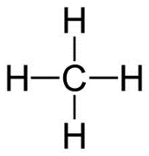
2 |  | C₂H₆
3
4

3. Alkanes form a Homologous Series. HOMOLOGOUS means that they have similar PROPERTIES and STRUCTURE, differing only by ____________

Alkenes
4. The general formula for alkenes is

C H

A. Number of Carbon Atoms | B. Displayed Formula | C. Molecular Formula | 7. Name | 6. Boiling Point (°C)
2
3
4
5
6

5. Outline some key differences between Alkanes and Alkenes:

