**Level 3 Applied Science September 2020 start**

Dear Level 3 Applied Science students,

This pack contains a programme of useful activities and resources to prepare you to make excellent start to your Level 3 studies in September. You should aim to complete it in the summer term and over the summer holidays to ensure you are ready to start your course in September.

The RQF BTEC Level 3 National Extended Diploma in Applied Science involves internal assessments (60%) and external assessments (40%), and these resources aim to help you develop your independent study skills needed for your assignments and help prepare you for the examinations.

In the first year of the course, you will all study the same units giving you a solid foundation for your chosen specialist units in Year 2. The two routes you can choose from are **Biomedical Science** or **Analytical and Forensic Science.**

**Books**

This is the textbook we recommend that you buy. Costs vary depending on which retailer you use. It can range from £14- up to £27, but it provides you with all the information you will need for the mandatory units in Year 1 of the course.



You will also find your GCSE books useful to recap some key topics which will appear in your Level 3 Applied Science programme.

This resource pack is split up as follows-:

|  |  |
| --- | --- |
| Biology | Pages 2-16 |
| Chemistry | Pages 14-26 |
| Physics | Pages 27-52 |

**Biology**

|  |  |
| --- | --- |
|  | **Themes** |
| 1 | Neuroscience |
| 2 | Medicine |
| 3 | Forensic Archaeology |
| 4 | Forensic Entomology |
| 5 | The Structure of DNA |
| 6 | Antibiotic resistance |
| 7 | Genetically Modified organisms |
| 8 | Microbiology |
| 9 | Blood |

Theme: **Neuroscience**

1. **How do drugs affect the brain? (5 minute animated video)**

Most people will take a pill, receive an injection, or otherwise take some kind of medicine during their lives. But most of us don’t know anything about how these substances actually work. How can various compounds impact the way we physically feel, think, and even behave? Sara Garofalo explains how some drugs can alter the communication between cells in the brain.

[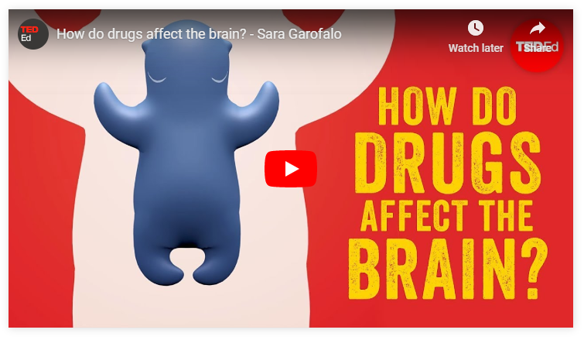https://ed.ted.com/lessons/how-do-drugs-affect-the-brain-sara-garofalo](https://ed.ted.com/lessons/how-do-drugs-affect-the-brain-sara-garofalo)

Watch this video and answer 5 multiple choice questions

**Quiz: How do drugs affect the brain?**

1. Which of the following is the quickest way for a drug to reach the bloodstream?

Choose one:

1. Oral administration
2. Intravenous injection
3. Inhalation
4. Which of the following is the slowest way for a drug to reach the bloodstream?

Choose one:

1. Oral administration
2. Inhalation
3. Intravenous injection
4. What is the function of the blood-brain barrier?

Choose one:

1. To keep all external substances out of the brain
2. To let substances inside the brain by favoring blood circulation in the nervous system
3. To separate the blood from the nervous system, thus keeping potentially dangerous substances out
4. Complete the sentence: “Synapses are structures ________, and allow the exchange of electrochemical signals between neurons.

Choose one:

1. Placed on the sending neuron
2. Of interconnection between sending and receiving neuron
3. Placed on the receiving neuron
4. How can a neurotransmitter modulate synaptic transmission?

Choose one:

1. By increasing the activity of the receiving neuron
2. By inhibiting the activity of the receiving neuron
3. Both a and b
4. **Tackling drug addiction (14 minute talk)**

What really causes addiction -- to everything from cocaine to smart-phones? And how can we overcome it? Johann Hari has seen our current methods fail first-hand, as he has watched loved ones struggle to manage their addictions. He started to wonder why we treat addicts the way we do -- and if there might be a better way. As he shares in this deeply personal talk, his questions took him around the world, and unearthed some surprising and hopeful ways of thinking about an age-old problem.

[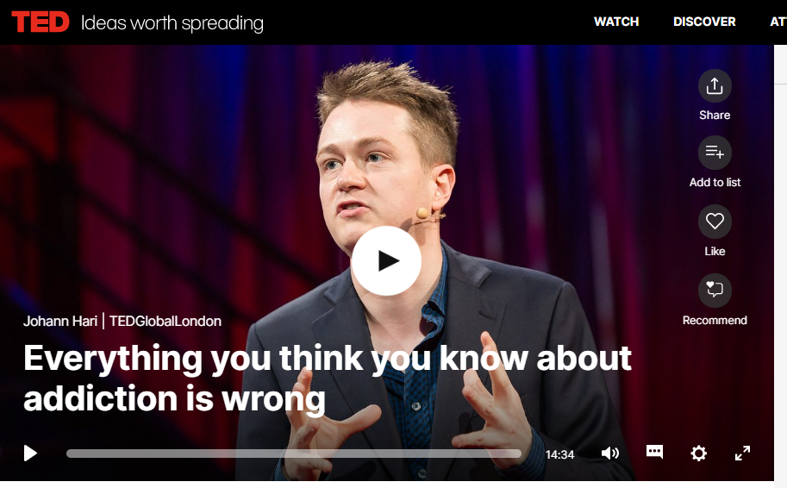https://www.ted.com/talks/johann_hari_everything_you_think_you_know_about_addiction_is_wrong?language=en](https://www.ted.com/talks/johann_hari_everything_you_think_you_know_about_addiction_is_wrong?language=en)

Theme: **Medicine**

1. **Placebo effect (4 minute animated video)**

The placebo effect is an unexplained phenomenon wherein drugs, treatments, and therapies that aren't supposed to have an effect — and are often fake — miraculously make people feel better. What's going on? Emma Bryce dives into the mystery of placebos' bizarre benefits.

[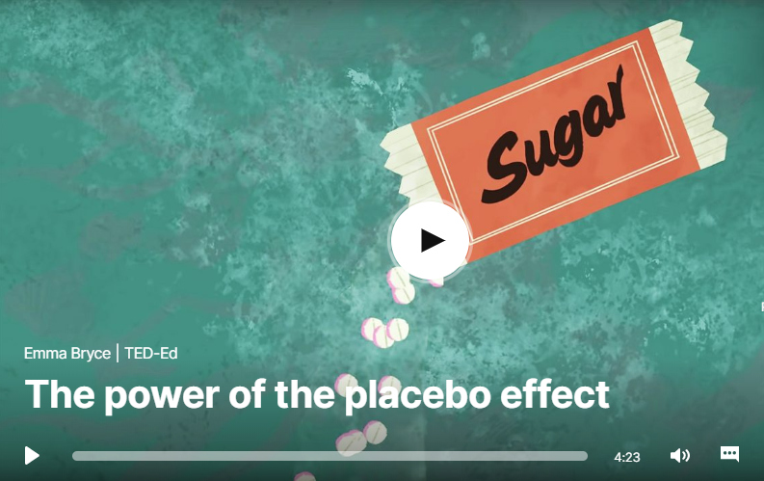](https://ed.ted.com/lessons/the-power-of-the-placebo-effect-emma-bryce)<https://www.ted.com/talks/emma_bryce_the_power_of_the_placebo_effect>

Watch this video and answer 5 multiple choice questions

**Quiz: Placebo effect**

1. What is the placebo effect?

Choose one:

1. It’s what happens when painkillers make your pain disappear
2. It’s an imagined phenomenon in medicine
3. It’s what occurs when a treatment has an effect even though it’s fake
4. It’s a figment of someone’s imagination
5. Trivaricaine was a real, effective painkiller

Choose one:

1. True
2. False
3. The term “placebo” comes from Latin, and means:

Choose one:

1. I shall please
2. Fake treatment
3. Pretend drug
4. False benefit
5. Placebos can take the form of:

Choose one:

1. Active treatments
2. Fake injections, sugar pills, sham surgeries, and other false treatments
3. Old pills
4. Unused drugs
5. Patients in pain studies sometimes feel the benefits of placebos because:

Choose one:

1. They’re confused
2. They're faking their symptoms
3. The placebos are actually real drugs
4. Placebos can be associated with a release of endorphins, which reduces pain
5. **Battling bad science (14 minute talk)**

Every day there are news reports of new health advice, but how can you know if they're right? Doctor and epidemiologist Ben Goldacre shows us, at high speed, the ways evidence can be distorted, from the blindingly obvious nutrition claims to the very subtle tricks of the pharmaceutical industry.

[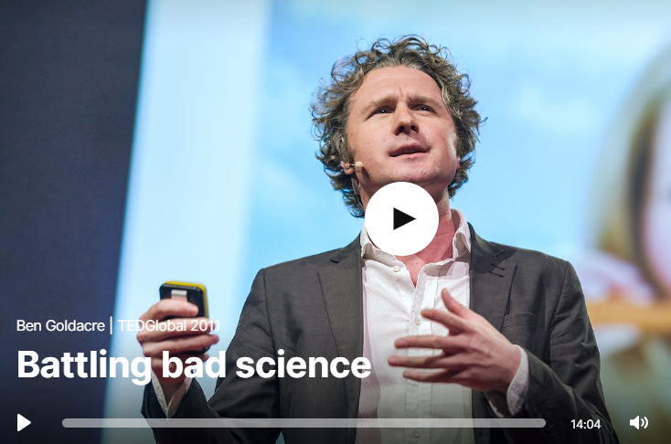https://www.ted.com/talks/ben_goldacre_battling_bad_science](https://www.ted.com/talks/ben_goldacre_battling_bad_science)

Theme: **Forensics**

**Forensic Archaeology**

The clip below is called “Solving the mystery of an ancient death” and looks at the role of forensic archaeology. For further information go to this website [www.DigSchool.org.uk](http://www.DigSchool.org.uk)

<https://www.youtube.com/watch?v=_XqVBr6-gY4&fbclid=IwAR0QBXGbqUfOF1J3cfOUZKkyc_vp_rZUIHeHPQlHNgAnb7LPxM2DzMwF0bk>

**Forensic Entomology**

The following clip shows the role of a forensic entomologist within an investigation.

<https://www.youtube.com/watch?v=HIVKISCmjTQ>

Theme: **Biological molecules (DNA)**

1. **Animations of molecules inside cells e.g. DNA (8 minute talk)**

Drew Berry creates stunning and scientifically accurate animations to illustrate how the molecules in our cell move and interact.

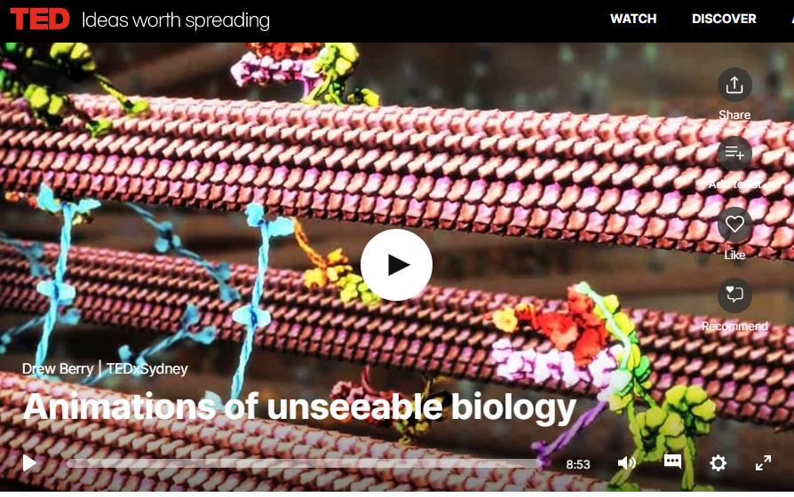<https://www.ted.com/talks/drew_berry_animations_of_unseeable_biology#t-345840>

1. **Editing DNA using CRISPR technology (15 minute talk)**

Geneticist Jennifer Doudna co-invented a ground-breaking new technology for editing genes, called CRISPR-Cas9. The tool allows scientists to make precise edits to DNA strands, which could lead to treatments for genetic diseases ... but could also be used to create so-called "designer babies." Doudna reviews how CRISPR-Cas9 works -- and asks the scientific community to pause and discuss the ethics of this new tool.

[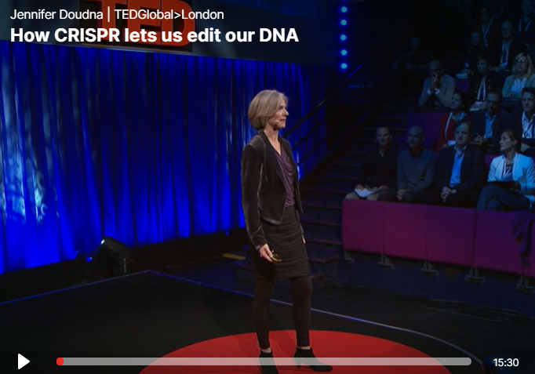https://www.ted.com/talks/jennifer_doudna_how_crispr_lets_us_edit_our_dna?referrer=playlist-how_does_dna_work#t-11040](https://www.ted.com/talks/jennifer_doudna_how_crispr_lets_us_edit_our_dna?referrer=playlist-how_does_dna_work#t-11040)

Theme: **Antibiotic resistance**

1. **How can we solve the antibiotic resistance crisis? (6 minute animated video)**

Antibiotics enable much of modern medicine. We use them to cure infectious diseases, and to safely facilitate everything from surgery to chemotherapy to organ transplants. But we’ve stopped discovering new ones and we’re at risk of losing them forever. How did we get into this situation? Gerry Wright shares what we can do about antibiotic resistance.

[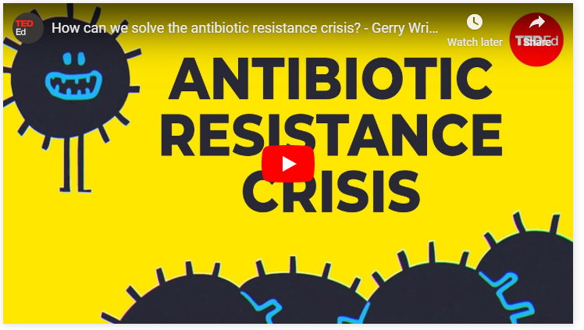https://ed.ted.com/lessons/how-can-we-solve-the-antibiotic-resistance-crisis-gerry-wright](https://ed.ted.com/lessons/how-can-we-solve-the-antibiotic-resistance-crisis-gerry-wright)

Watch this video and answer 5 multiple choice questions

**Quiz: Antibiotic resistance crisis**

1. Antibiotics are used for all the following, except:

Choose one answer

1. Organ transplant
2. Organ implant
3. Chemotherapy
4. Killing viruses
5. Many bacteria are resistant to all currently available antibiotics
6. True
7. False
8. Discovered in 1928, Alexander Fleming discovered the first widely used antibiotic,

Choose one answer

1. Penicillin
2. Macrolides
3. Aminoglycosides
4. Cephalosporins
5. Which of the following is not an effective way to battle antibiotic resistance:

Choose one answer

1. Control the use of antibiotics
2. Create new antibiotics
3. Prescribe antibiotics for viral infections
4. Combat resistance to antibiotics
5. The largest consumer of antibiotics is:

Choose one answer

1. Local hospitals
2. Agriculture
3. Care homes
4. Educational institutions

**Ideas to consider/research:-**

* Do you think it is ethical to use antibiotics to promote the growth of good animals? Why or why not?
* What are the biggest health issues posed by antibiotic misuse and antibiotic resistance?
* Why and how does resistance emerge in bacteria?

1. **What do we do when antibiotics don’t work anymore? (16 minute talk)**

Penicillin changed everything. Infections that had previously killed were suddenly quickly curable. Yet as Maryn McKenna shares in this sobering talk, we've squandered the advantages afforded us by that and later antibiotics. Drug-resistant bacteria mean we're entering a post-antibiotic world -- and it won't be pretty. There are, however, things we can do ... if we start right now.

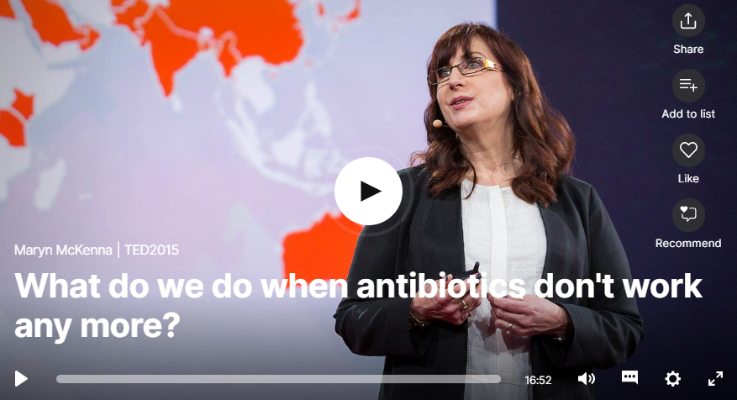<https://www.ted.com/talks/maryn_mckenna_what_do_we_do_when_antibiotics_don_t_work_any_more>

Theme: **Genetically modified organisms**

1. **Are GMOs good or bad? (6 minute animated video)**

Are GMOs bad for your health? Or is this fear unfounded? Kurzgesagt investigates the impact genetic engineering has on our food.

[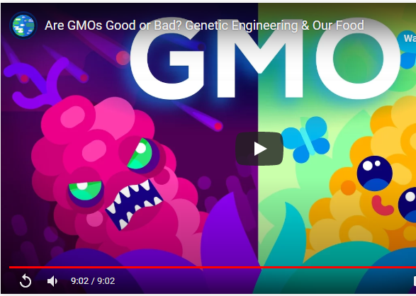https://ed.ted.com/best_of_web/0HAnxvLF#watch](https://ed.ted.com/best_of_web/0HAnxvLF#watch)

1. **Can we engineer crops that can survive in drought conditions? (14 minute talk)**

As the world's population grows and the effects of climate change come into sharper relief, we'll have to feed more people using less arable land. Molecular biologist Jill Farrant studies a rare phenomenon that may help: "resurrection plants" -- super-resilient plants that seemingly come back from the dead. Could they hold promise for growing food in our coming hotter, drier world?

[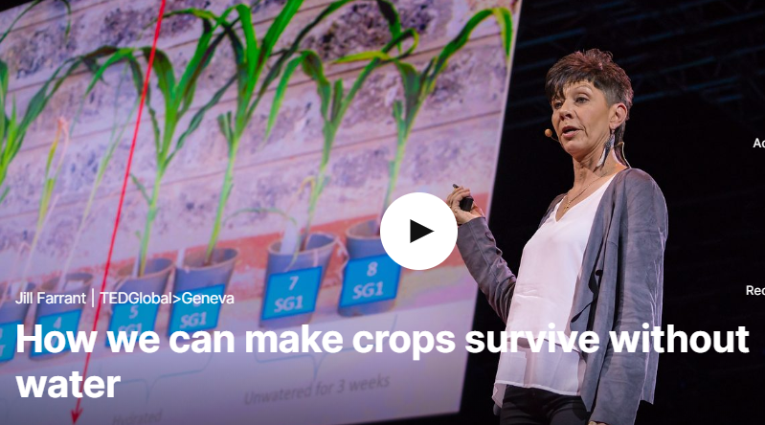https://www.ted.com/talks/jill_farrant_how_we_can_make_crops_survive_without_water#t-823873](https://www.ted.com/talks/jill_farrant_how_we_can_make_crops_survive_without_water#t-823873)

Theme: **Microorganisms**

1. **Microorganisms and you (4 minute animated video)**

From the microbes in our stomachs to the ones on our teeth, we are homes to millions of unique and diverse communities which help our bodies function. Jessica Green and Karen Guillemin emphasize the importance of understanding the microorganisms that make up each and every organism.

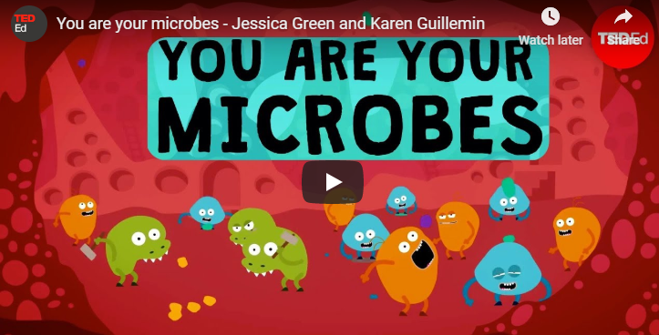<https://ed.ted.com/lessons/you-are-your-microbes-jessica-green-and-karen-guillemin>

Watch this video and answer 5 multiple choice questions

**Quiz: Microorganisms and you**

1. Approximately how many microscopic beings inhabit our bodies?

Choose one answer

1. 100
2. Thousands
3. Millions
4. None
5. What is a cellulolytic bateria's one job?

Choose one answer

1. Sort monosaccharides
2. Kill harmful bacteria
3. Digest excess white blood cells
4. Break down cellulose
5. As food travels through the digestive tract, it reaches the fermenters. What do they do?

Choose one answer

1. Create proteins by fermenting carbohydrates (a slow process)
2. Extract energy from sugars by converting them to chemicals (like alcohol)
3. Catalyse digestion by fermenting waste
4. All of the above
5. One person's gut microbes may be capable of releasing only a fraction of the calories that another person's gut microbes can extract.
6. True
7. False
8. What happens when a person eats only foods made of simple molecules?

Choose one answer

1. Lots of different microbial workers are required to break down the food (causing a much more diverse gut microbial ecosystem)
2. Only a few microbial workers are required to break down the food (causing a less diverse gut microbial ecosystem)
3. Scientists are still uncertain exactly what happens to a person because of the foods that he/she eat
4. All of the above
5. **How our microbes make us who we are (17 minute talk)**

Rob Knight is a pioneer in studying human microbes, the community of tiny single-cell organisms living inside our bodies that have a huge — and largely unexplored — role in our health. “The three pounds of microbes that you carry around with you might be more important than every single gene you carry around in your genome,” he says. Find out why.

[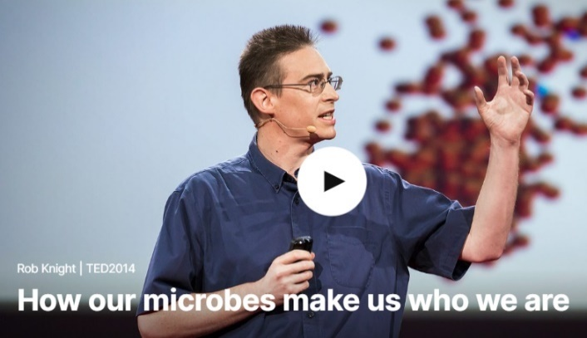https://www.ted.com/talks/rob_knight_how_our_microbes_make_us_who_we_are](https://www.ted.com/talks/rob_knight_how_our_microbes_make_us_who_we_are)

Theme: **Blood**

1. **How do blood transfusions work? (4 minute animated video)**

In 1881, doctor William Halsted rushed to help his sister Minnie, who was haemorrhaging after childbirth. He quickly inserted a needle into his arm, withdrew his own blood, and transferred it to her. After a few uncertain minutes, she began to recover. What made this blood transfusion successful? Bill Schutt explains the history of the life-saving procedure.

[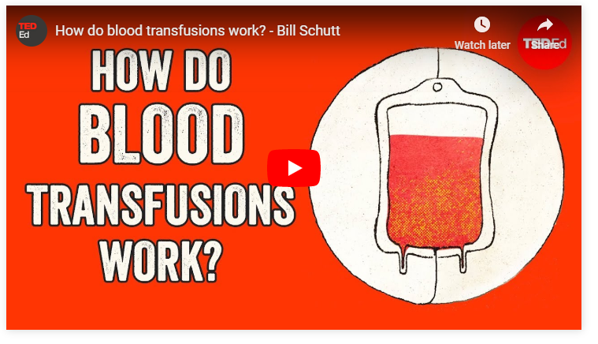https://ed.ted.com/lessons/how-does-blood-transfusion-work-bill-schutt](https://ed.ted.com/lessons/how-does-blood-transfusion-work-bill-schutt)

Watch this video and answer 4 multiple choice questions

**Quiz: How do blood transfusions work?**

1. Antigens are

Choose one answer

1. Proteins produced by the immune system to combat intruders like bacteria or foreign cells
2. Bacteria or cells that can enter the body and cause medical problems
3. Proteins imbedded in the cell membranes of intruders like bacteria or foreign cells
4. Different blood types that can cause problems if transfused into the wrong person
5. Why were the first successful transfusions limited to real time procedures between donor and recipient

Choose one answer

1. Because donor blood quickly clots when removed from the body
2. Because it enabled physicians to quickly transfuse more blood if it was needed
3. So that they could give the donor and recipient sodium citrate if it was needed
4. Because blood could only be transfused between family members
5. Antibodies are

Choose one answer

1. Proteins produced by the immune system to combat intruders like bacteria or foreign cells
2. Bacteria or cells that can enter the body and cause medical problems
3. Proteins imbedded in the cell membranes of intruders like bacteria or foreign cells
4. Different blood types that can cause problems if transfused into the wrong person
5. Why did sheep blood recipient Antoine Mauroy develop pain in his lower back?

Choose one answer

1. Because the transfused blood caused muscle cramps in his back
2. Because bacteria in the transfused blood had likely caused a urinary tract infection
3. Because blood clots and destroyed red blood cells disrupted the function of his kidneys
4. Because antibodies in the sheep blood reacted with antigens in Mauroy’s back and kidneys
5. **How disease can change the shape of red blood cells (4 minute animated video)**

[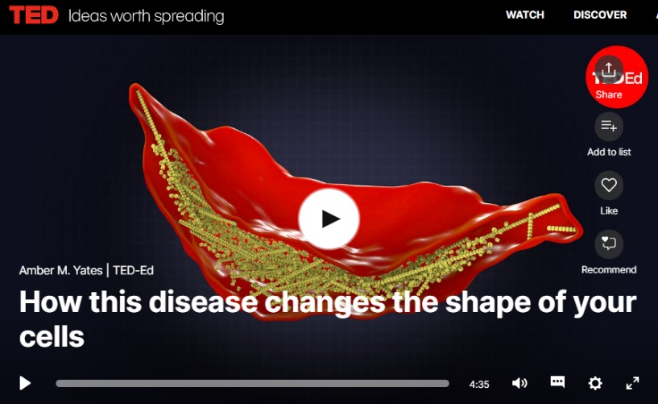](https://www.ted.com/talks/amber_m_yates_how_this_disease_changes_the_shape_of_your_cells)What shape are your cells? Squishy cylinders? Jagged zig-zags? Small variations can have huge consequences. While some adaptations change these shapes for the better, others can spark debilitating complications. Amber M. Yates dives into the science of the malignant sickle-cell mutation.

Watch this video and answer 5 multiple choice questions

**Quiz: How do blood transfusions work?**

1. Having sickle cell trait reduces your risk of getting what infection?

Choose one answer

1. Influenza
2. Malaria
3. Pneumonia
4. Whooping cough
5. What shape should your red blood cells be?

Choose one answer

1. Banana
2. Doughnut
3. Tear drop
4. Sphere
5. What complication can a patient with sickle cell anemia have if the blood flow in the brain is blocked?

Choose one answer

1. Meningitis
2. Pneumonia
3. Retinal detachment
4. Stroke
5. How many months should your red blood cells survive?

Choose one answer

1. One
2. Two
3. Three
4. Four
5. What protein is affected in sickle cell disease?

Choose one answer

1. Albumin
2. Haemoglobin
3. Keratin
4. Insulin
5. **Life-saving device that detects silent heart attacks (8 minute talk)**

Hear from a 17 year old inventor of a life-saving device that detects silent heart attacks.

The common symptoms of a heart attack are chest and arm pain, shortness of breath and fatigue. But there's another kind that's just as deadly and harder to detect because the symptoms are silent. In this talk, 17-year-old inventor Akash Manoj shares the device he's developed to stop this silent killer: a noninvasive, inexpensive, wearable patch that alerts patients during a critical moment that could mean the difference between life and death.

[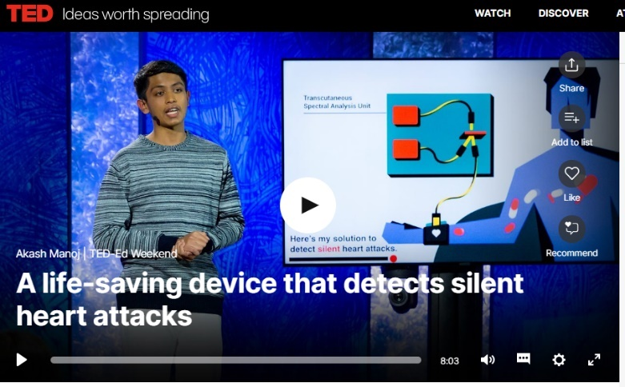https://www.ted.com/talks/akash_manoj_a_life_saving_device_that_detects_silent_heart_attacks](https://www.ted.com/talks/akash_manoj_a_life_saving_device_that_detects_silent_heart_attacks)

**Answers to multiple choice questions**

|  |  |  |  |  |  |
| --- | --- | --- | --- | --- | --- |
| **Quiz** | **Q1** | **Q2** | **Q3** | **Q4** | **Q5** |
| **How do drugs affect the brain?** | b | a | c | b | c |
| **Placebo effect** | c | b | a | b | d |
| **Antibiotic resistance** | d | a | a | c | b |
| **Microorganisms and you** | c | d | d | a | b |
| **How do blood transfusions work?** | c | a | a | c |  |
| **Sickle cell disease** | b | b | d | d | b |

**Chemistry**

**Online learning revision activities.**

Some of these links take you to online games / puzzles others to some written questions activities

|  |  |
| --- | --- |
| **Topic** | **Some useful Links to online activities** |
| Multiple topics:  The following will be useful with this link:   * Acids * Alkalis * Alcohols * Alkanes * Allotropes of carbon * Atomic structure * Everyday chemicals * Ionic formula 1 & 2 * Mole equations * Multiples of units * State symbols * Subatomic particles * Tests for anions * Types of bonding * Units of volume | <http://www.rsc.org/learn-chemistry/resources/gridlocks/level-2.html>  (Puzzle online games based on moles equations & units, acids & bases, bonding, atomic structure).  These should help you recap some of your GCSE knowledge. |
| Basic practical competencies | <https://edu.rsc.org/resources/basic-practical-competencies-starters-16andndash18/4010260.article> |
| Basic essential Chemistry skills | <https://edu.rsc.org/resources/basic-chemistry-competencies-starters-16andndash18/4010256.article> |
| Key math’s skills for chemists | <https://edu.rsc.org/resources/basic-mathematical-competencies-starters-16andndash18/4010259.article> |
| Atomic structure | <https://phet.colorado.edu/en/simulation/build-an-atom> Atomic structure revision simulation |
| Online Titration screen experiment. There are multiple difficulty levels to try! | <http://www.rsc.org/learn-chemistry/resources/screen-experiment/titration/experiment/2> |
| Equilibria:  Download the attached document and complete the quick 10 mark quizzes.  Answers are at the back of the document. | <https://edu.rsc.org/resources/equilibria-starters-1-16andndash18/4010277.article> |
| Interactive physical chemistry simulations | <https://edu.rsc.org/resources/collections/phet-interactive-simulations> |
| You tube link to recap bonding. | https://www.youtube.com/user/virtualschooluk/search?query=bonding |

Watch:

Follow the link to recap some of your GCSE Chemistry!

<https://www.youtube.com/channel/UCqbOeHaAUXw9Il7sBVG3_bw/videos>

Questions to answer:

You should further prepare for the chemistry in your Level 3 Applied Science, by practicing some GCSE exam questions. A link to some exam board websites below you should look at the **Higher tier papers**!

AQA: <https://www.aqa.org.uk/subjects/science/gcse/chemistry-8462/assessment-resources?f.Resource+type%7C6=Question+papers&sort=date&num_ranks=20&start_rank=1>

OCR: <https://www.ocr.org.uk/qualifications/gcse/gateway-science-suite-chemistry-a-j248-from-2016/assessment/>

Below are some exam questions to practice and a quick alkane and alkene summary task:

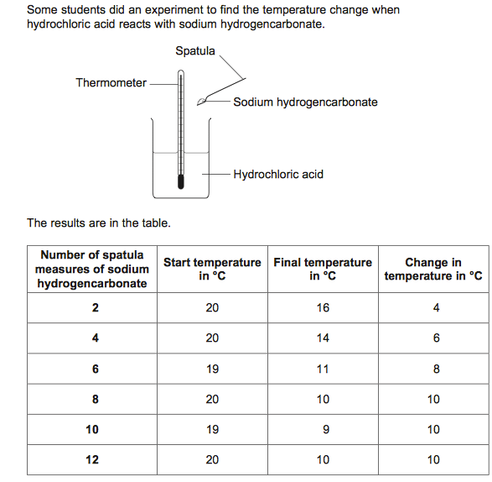

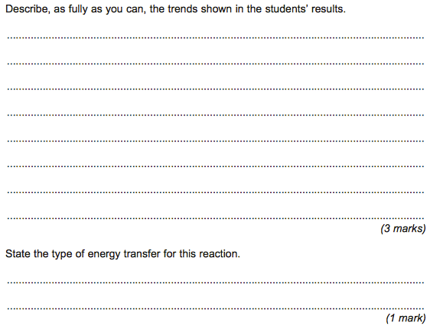

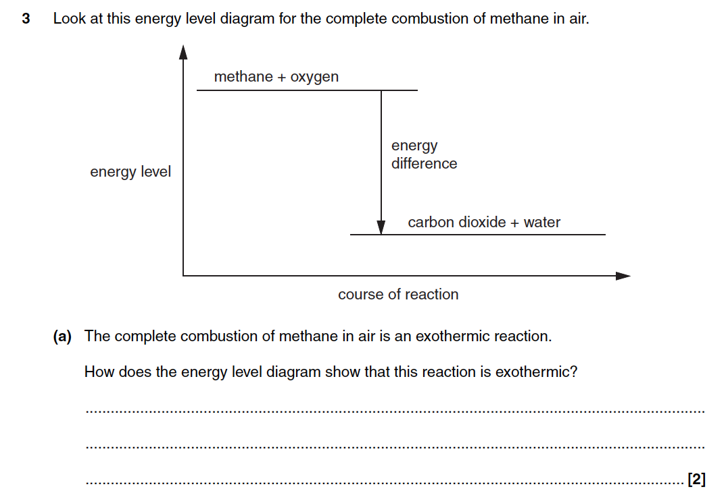

**Q1.**In 1909 Fritz Haber invented a process to produce ammonia from nitrogen and hydrogen.

(a)     Complete and balance the chemical equation for the production of ammonia from nitrogen and hydrogen.

N2      +      3 H2            ....................

**(2)**

(b)     The figure below shows how the equilibrium yield of ammonia changes with pressure at different temperatures.

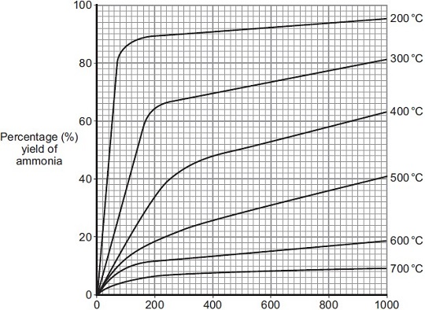   
                    Pressure in atmospheres

(i)      Use the information in given in the figure to complete the sentence.

The temperature on the graph that gives the highest yield of ammonia is ................. °C.

**(1)**

(ii)     The temperature used in the Haber process for the production of ammonia is 450 °C.

Why is a temperature much lower than 450 °C **not** used for the Haber process?

...............................................................................................................

...............................................................................................................

**(1)**

(iii)    Use the information in the figure to answer this question.

Draw a ring around the pressure that gives the highest yield of ammonia.

|  |  |  |  |  |
| --- | --- | --- | --- | --- |
|  | **100** | **200** | **300** | **400** |

**(1)**

(iv)    The pressure used in the Haber process for the production of ammonia is 200 atmospheres.

Why is a pressure lower than 200 atmospheres **not** used for the Haber process?

...............................................................................................................

...............................................................................................................

**(1)**

**(Total 8 marks)**

**Q2.**A company manufactures ethanol (C2H5OH).

The reaction for the process is:

C2H4(g) + H2O(g)        C2H5OH(g)            Δ*H* = −45 kJ per mole

The temperature and pressure can be changed to increase the yield of ethanol at equilibrium.

(a)     Explain what is meant by equilibrium.

........................................................................................................................

........................................................................................................................

........................................................................................................................

**(3)**

(b)     (i)      How would increasing the temperature change the **yield** of ethanol at equilibrium?

Give a reason for your answer.

...............................................................................................................

...............................................................................................................

...............................................................................................................

...............................................................................................................

...............................................................................................................

**(2)**

(ii)     How would increasing the pressure change the **yield** of ethanol at equilibrium?

Give a reason for your answer.

...............................................................................................................

...............................................................................................................

...............................................................................................................

...............................................................................................................

...............................................................................................................

**(2)**

(c)     A catalyst is added to increase the rate of the reaction.

Explain how adding a catalyst increases the rate of a chemical reaction.

........................................................................................................................

........................................................................................................................

........................................................................................................................

........................................................................................................................

**(2)**

**(Total 9 marks)**

**M1.**(a)     2NH3

*allow NH3 with incorrect or missing balancing for* ***1*** *mark*

*allow multiples*

**2**

(b)     (i)      200

**1**

(ii)     rate of reaction (too) slow

*allow converse*

*ignore references to yield / cost*

**1**

(iii)    400

**1**

(iv)    lower yield

*allow converse*

*accept shifts equilibrium to left*

*allow favours the backward reaction*

*allow favours side with more (gaseous) molecules*

*allow lower rate*

**1**

**[8]**

**M2.**(a)     the forward and backward reactions occur

*allow reversible*

**1**

at (exactly) the same rate

**1**

in a closed system

*allow therefore the concentrations / amounts of the reactants and products remain the same*

**1**

(b)     (i)      increasing the temperature would lower the yield of ethanol **or** the (position of) equilibrium moves to the left

*if student has stated that increasing the temperature increases the yield then award* ***0*** *marks*

**1**

since the backwards reaction is endothermic **or** the forward reaction is exothermic

**1**

(ii)     increasing the pressure would increase the yield of ethanol **or** the (position of) equilibrium moves to the right

*if student has stated that increasing the pressure decreases the yield then award* ***0*** *marks*

**1**

because the position (of equilibrium) moves in the direction of the lower number of moles (of gas)

*2 (moles / molecules / volumes / particles) on lhs / 1 (mole / molecule / volume / particle) on rhs*

(c)     (a catalyst) provides an alternative pathway

**1**

with lower activation energy

**or**

(a catalyst) lowers the activation energy (1)

so less energy is needed to react **or** more particles react (1)

**1**

**[9**

**Alkanes & Alkenes quick task**

1. The general formula for alkanes is

C H

2. A **HYDROCARBON** is a compound that contains CARBON and HYDROGEN only.

|  |  |  |  |  |
| --- | --- | --- | --- | --- |
| A. Number of Carbon Atoms | B. Displayed Formula | C. Molecular Formula | 7. Name | 6. Boiling Point (**°**C) |
| 1 |  |  |  |  |
| 2 |  | C2H6 |  |  |
| 3 |  |  |  |  |
| 4 |  |  |  |  |

3. Alkanes form a Homologous Series. **HOMOLOGOUS** means that they have similar PROPERTIES and STRUCTURE, differing only by ____________

**Alkenes**

4. The general formula for alkenes is

C H

|  |  |  |  |  |
| --- | --- | --- | --- | --- |
| A. Number of Carbon Atoms | B. Displayed Formula | C. Molecular Formula | 7. Name | 6. Boiling Point (**°**C) |
| 2 |  |  |  |  |
| 3 |  |  |  |  |
| 4 |  |  |  |  |
| 5 |  |  |  |  |
| 6 |  |  |  |  |

Outline some key differences between **Alkanes** and **Alkenes:**

**Physics**

**Atomic Basics**

There are several models of the atom.

|  |  |  |
| --- | --- | --- |
|  |  |  |
| The Solid Sphere Model | The Plum Pudding Model | The Nuclear Model |

The Solid Sphere model assumed that the atom was a solid ball like a snooker or golf ball.

The Plum Pudding model describes the atoms as a positive ‘dough’ with negative charges scattered through it at random.

Describe and draw the nuclear model of the atom.

_________________________________________________________________________________________________

_________________________________________________________________________________________________

_________________________________________________________________________________________________

_________________________________________________________________________________________________

_________________________________________________________________________________________________

_________________________________________________________________________________________________

Complete the table below.

|  |  |  |  |  |
| --- | --- | --- | --- | --- |
| Particle |  | Relative Charge | Relative  Mass | Where is it found? |
| Proton |  |  |  |  |
| Neutron |  |  |  |  |
| Electron |  |  |  |  |

The periodic table displays all the different types of atoms/elements that exist. The boxes on the table look like the ones below:

Explain what the notation in the box tells us (not these specific examples):

|  |  |  |  |  |
| --- | --- | --- | --- | --- |
| 1 | 9 | 32 | 40 | 80 |
| 2 | Be | P | Ca | Br |
| 3 | Beryllium | Phosphorus | Calcium | Bromine |
| 4 | 4 | 15 | 20 | 35 |

1: ____________________________________________

2: ____________________________________________

3: ____________________________________________

4: ____________________________________________

How do you work out the number of neutrons that are in an atom?

_________________________________________________________________________________________________

________________________________________________________________________________________________

An atom is neutral because it has the same number of positive ___________________ as it has negative ________________

How do you work out the number of electrons that are in an atom?

_________________________________________________________________________________________________

Use the periodic table to help you complete the table below

|  |  |  |  |  |  |  |  |
| --- | --- | --- | --- | --- | --- | --- | --- |
| Number | Name | Symbol | Protons | Neutrons | Electrons | Atomic Number | Mass Number |
| 1 | Hydrogen |  |  |  |  |  |  |
| 2 | Helium |  |  |  |  |  |  |
| 3 | Lithium |  |  |  |  |  |  |
| 4 |  | Be |  |  |  |  |  |
| 5 |  | B |  |  |  |  |  |
| 6 |  | C |  |  |  |  |  |
| 7 | Nitrogen |  |  |  |  |  |  |
| 8 |  | O |  |  |  |  |  |
| 9 | Fluorine |  |  |  |  |  |  |
| 10 |  | Ne |  |  |  |  |  |

Isotopes are different versions of the same element. They all have the same number of ________________________ but a different number of _____________________

Calculate the number of protons, neutrons and electrons of these isotopes

|  |  |  |  |  |  |  |
| --- | --- | --- | --- | --- | --- | --- |
| Isotope | $${}_{92}^{233}U$$ | $${}_{92}^{235}U$$ | $${}_{92}^{238}U$$ | $${}_{6}^{12}C$$ | $${}_{6}^{13}C$$ | $${}_{6}^{14}C$$ |
| Protons |  |  |  |  |  |  |
| Neutrons |  |  |  |  |  |  |
| Electrons |  |  |  |  |  |  |

|  |  |  |  |  |  |  |
| --- | --- | --- | --- | --- | --- | --- |
| Isotope | $${}_{17}^{35}{Cl}$$ | $${}_{17}^{37}{Cl}$$ | $${}_{26}^{54}{Fe}$$ | $${}_{26}^{56}{Fe}$$ | $${}_{79}^{197}{Au}$$ | $${}_{79}^{195}{Au}$$ |
| Protons |  |  |  |  |  |  |
| Neutrons |  |  |  |  |  |  |
| Electrons |  |  |  |  |  |  |

|  |
| --- |
|  |
|  |
|  |
|  |

|  |
| --- |
|  |
|  |
|  |
|  |

**Radioactivity**

Some isotopes are stable and others are radioactive.

Draw the hazard symbol for radioactive and toxic in these boxes.

Explain what the following words mean.

Radioactive ______________________________________________________________________________________________

________________________________________________________________________________________________

Decay____________________________________________________________________________________________

_________________________________________________________________________________________________

Radiation ________________________________________________________________________________________________

________________________________________________________________________________________________

Stable____________________________________________________________________________________________

_________________________________________________________________________________________________

Different radioactive isotopes have different half-lives. If a radioactive isotope has a long half-life it means that

_________________________________________________________________________________________________

If a radioactive isotope has a short half-life it means that ________________________________________________________________________________________________

_________________________________________________________________________________________________

Write an explanation of what half-life is.

_________________________________________________________________________________________________

_________________________________________________________________________________________________

The real life scenarios below are like radioactivity. Read them through and fill in the table

|  |  |  |
| --- | --- | --- |
| What represents… | Sally has eaten something undercooked and is feeling unwell. She goes to the toilet and is sick. When she comes out she is feeling much better. | Harry is up a ladder painting a wall green. He is holding onto the ladder with one hand and five cans of paint and a brush in the other. The ladder is very wobbly. He decides to drop four of the cans so he can hold onto the ladder better. |
| Radioactive? |  |  |
| Decay? |  |  |
| Radiation? |  |  |
| Stable? |  |  |

**Ionising Radiation**

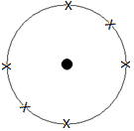This is a diagram of an atom, it has the same number of positive ______________________ in

the nucleus as it has negative _____________________ orbiting the nucleus.

The nucleus is strongly bonded together so particles inside it almost never get out.

Explain what an ion is

_________________________________________________________________________________________________

Explain how the following ions are formed from the atom above. Include a diagram like the one above to help with your explanation.

|  |  |
| --- | --- |
| A positive 1+ ion | A negative 1– ion |
| A positive 2+ ion | A negative 2– ion |

Explain what radiation is and where it comes from.

_________________________________________________________________________________________________

_________________________________________________________________________________________________

Explain what ionising radiation is.

_________________________________________________________________________________________________

_________________________________________________________________________________________________

_________________________________________________________________________________________________

**Alpha, Beta and Gamma**

Complete these tables about the different types of radiation.

|  |  |  |
| --- | --- | --- |
| Type of Radiation | What is it? What is it made from? | Diagram |
| Alpha |  |  |
| Beta |  |  |
| Gamma |  |  |

|  |  |  |  |  |  |
| --- | --- | --- | --- | --- | --- |
| Type of Radiation | Relative Charge | Relative Mass | Ionising Power | Deflected by EM Field? | What is it stopped by? |
| Alpha |  |  |  |  |  |
| Beta |  |  |  |  |  |
| Gamma |  |  |  |  |  |

Draw lines to show which source should be stored in each box so that the risk of radiation leakage is a minimum



A radioactive source emits alpha, beta and gamma radiation. The diagram shows what happens to the radiation as it passes between two charged plates.



Identify which types of radiation P, Q and R are.

|  |  |  |  |  |  |
| --- | --- | --- | --- | --- | --- |
| P |  | Q |  | R |  |

**Dangers of Alpha, Beta and Gamma Radiation**

Some foods are exposed to radiation to make them last longer on the supermarket shelves. Some people stop buying these foods when they find this out, why do you think they do that?

_________________________________________________________________________________________________

_________________________________________________________________________________________________

List some of the ways we use radioactive isotopes in our homes and in industry.

_________________________________________________________________________________________________

_________________________________________________________________________________________________

_________________________________________________________________________________________________

_________________________________________________________________________________________________

Describe and explain the possible dangers from having the following types of radiation OUTSIDE our bodies.

Alpha ________________________________________________________________________________________________

_________________________________________________________________________________________________

Beta _________________________________________________________________________________________________

_________________________________________________________________________________________________

Gamma _________________________________________________________________________________________________

_________________________________________________________________________________________________

Describe and explain the possible dangers from having the following types of radiation INSIDE our bodies.

Alpha _________________________________________________________________________________________________

_________________________________________________________________________________________________

Beta _________________________________________________________________________________________________

_________________________________________________________________________________________________

Gamma _________________________________________________________________________________________________

_________________________________________________________________________________________________

Describe and explain the possible dangers from the different types of radiation on OBJECTS and NON-HUMAN LIFE.

_________________________________________________________________________________________________

_________________________________________________________________________________________________

_________________________________________________________________________________________________

_________________________________________________________________________________________________

_________________________________________________________________________________________________

_________________________________________________________________________________________________

**Why Do We Use Radiation?**

Radiation is used to control the thickness of paper, cardboard and aluminium when it is manufactured.

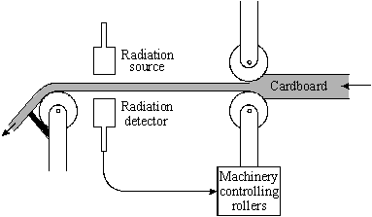Use the diagram to explain how radiation is used in this situation.

________________________________________________

________________________________________________

________________________________________________

________________________________________________

________________________________________________

________________________________________________

________________________________________________

_________________________________________________________________________________________________

_________________________________________________________________________________________________

How else could you do this job?

_________________________________________________________________________________________________

_________________________________________________________________________________________________

_________________________________________________________________________________________________

_________________________________________________________________________________________________

Outline the benefits of using radiation to do this job

_________________________________________________________________________________________________

_________________________________________________________________________________________________

_________________________________________________________________________________________________

_________________________________________________________________________________________________

Outline the drawbacks of radiation doing this job

_________________________________________________________________________________________________

_________________________________________________________________________________________________

_________________________________________________________________________________________________

_________________________________________________________________________________________________

Radiation is also used in smoke detectors.

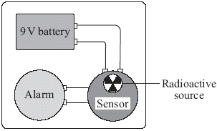Radiation passes between a source and a detector. If particles of smoke drift between the source and the detector the radiation is absorbed. The detector then triggers an alarm to alert us.

Outline the benefits of using radiation to do this job

___________________________________________________________

___________________________________________________________

___________________________________________________________

___________________________________________________________

Outline the drawbacks of radiation doing this job

_________________________________________________________________________________________________

_________________________________________________________________________________________________

_________________________________________________________________________________________________

_________________________________________________________________________________________________

Radiation is used to sterilise medical equipment like in the diagram. The radiation kills bacteria and viruses on the equipment.

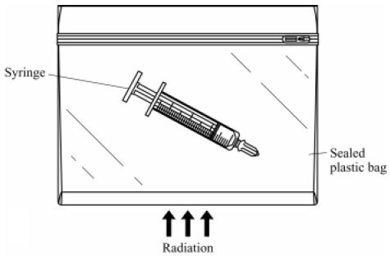Outline the benefits of using radiation to do this job

_________________________________________________

_________________________________________________

_________________________________________________

_________________________________________________

_________________________________________________

_________________________________________________

_________________________________________________

Outline the drawbacks of radiation doing this job

_________________________________________________________________________________________________

_________________________________________________________________________________________________

_________________________________________________________________________________________________

_________________________________________________________________________________________________

How else could you do this job?

_________________________________________________________________________________________________

_________________________________________________________________________________________________

_________________________________________________________________________________________________

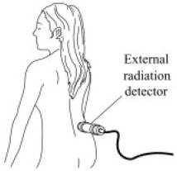Radiation can be used as a tracer in medical situations. Briefly explain what this involves.

_______________________________________________________________________

_______________________________________________________________________

_______________________________________________________________________

_______________________________________________________________________

_______________________________________________________________________

_______________________________________________________________________

How else could you do this job?

_________________________________________________________________________________________________

_________________________________________________________________________________________________

_________________________________________________________________________________________________

_________________________________________________________________________________________________

Outline the benefits of using radiation to do this job

_________________________________________________________________________________________________

_________________________________________________________________________________________________

_________________________________________________________________________________________________

Outline the drawbacks of radiation doing this job

_________________________________________________________________________________________________

_________________________________________________________________________________________________

_________________________________________________________________________________________________

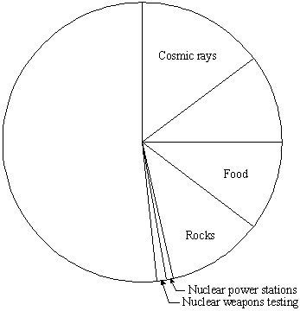We are exposed to a background level of radiation and have been all of our lives.

Complete the pie chart to show the main contributors to background radiation.

Which are the natural contributors to background radiation levels?

_____________________________________________________

_____________________________________________________

_____________________________________________________

Which are the manmade contributors to background radiation?

_____________________________________________________

_____________________________________________________

_____________________________________________________

**The Right Radiation for the Job**

Here is information about some different radioactive isotopes, the radiation they emit and their half-lives.

|  |  |  |  |  |  |  |
| --- | --- | --- | --- | --- | --- | --- |
| Isotope | Radiation emitted | Half-life |  | Isotope | Radiation emitted | Half-life |
| bismuth 83 | beta | 61 minutes |  | polonium 210 | alpha | 138 days |
| caesium 135 | beta | 3 million years |  | polonium-213 | alpha | 0.3 seconds |
| cobalt 60 | gamma | 5 years |  | radon 222 | alpha | 28 years |
| hydrogen-3 | beta | 12 years |  | technetium 99 | gamma | 6 hours |
| iridium-192 | gamma | 74 days |  | uranium-239 | beta | 24 minutes |

Which isotope would be best suited for controlling the thickness of paper? _____________________________________

Which isotope would be best suited for sterilising medical equipment? _________________________________________

Which isotope would be best suited for a household smoke detector? _________________________________________

Which isotope would be best suited to be injected as a medical tracer? ________________________________________

Choose two of your answers and justify why the isotope you have chosen is the most suitable.

_________________________________________________________________________________________________

_________________________________________________________________________________________________

_________________________________________________________________________________________________

_________________________________________________________________________________________________

________________________________________________________________________________________________

_________________________________________________________________________________________________

_________________________________________________________________________________________________

**Nuclear Fusion**

What is a nucleus? ________________________________________________________________________________

_________________________________________________________________________________________________

What is the difference between a nucleus and an atom? ___________________________________________________

________________________________________________________________________________________________

What does fuse mean? _____________________________________________________________________________

Explain what happens in nuclear fusion. You should include a diagram to support your explanation.

___________________________________________________

___________________________________________________

___________________________________________________

___________________________________________________

What are the conditions needed for nuclear fusion to happen?

_________________________________________________________________________________________________

_________________________________________________________________________________________________

Where does nuclear fusion happen?

_________________________________________________________________________________________________

________________________________________________________________________________________________

**Nuclear Fission**

What does fission mean? ___________________________________________________________________________________

Explain what happens in nuclear fusion. You should include a diagram to support your explanation.

___________________________________________________

___________________________________________________

___________________________________________________

___________________________________________________

___________________________________________________

What are the conditions needed for nuclear fission to happen?

_________________________________________________________________________________________________

_________________________________________________________________________________________________

Where does nuclear fission happen?

_________________________________________________________________________________________________

_________________________________________________________________________________________________

What does chain reaction mean?

_________________________________________________________________________________________________

_________________________________________________________________________________________________

Explain how a nuclear fission chain reaction happens. Include a diagram to support your explanation.

____________________________________________

____________________________________________

____________________________________________

____________________________________________

**Controlling Reactions**

Why can’t fusion reactions be used effectively on Earth? ___________________________________________________

_________________________________________________________________________________________________

_________________________________________________________________________________________________

What fuses together in stars? ­­­­­______________________________________

What does this become? ______________________________________

How could you stop fusion reactions happening?

_________________________________________________________________________________________________

_________________________________________________________________________________________________

Why are the fusion reactions in the Sun stable? Why will it keep going for millions of years?

_________________________________________________________________________________________________

_________________________________________________________________________________________________

_________________________________________________________________________________________________

How could you increase the rate of fission reactions?

_________________________________________________________________________________________________

_________________________________________________________________________________________________

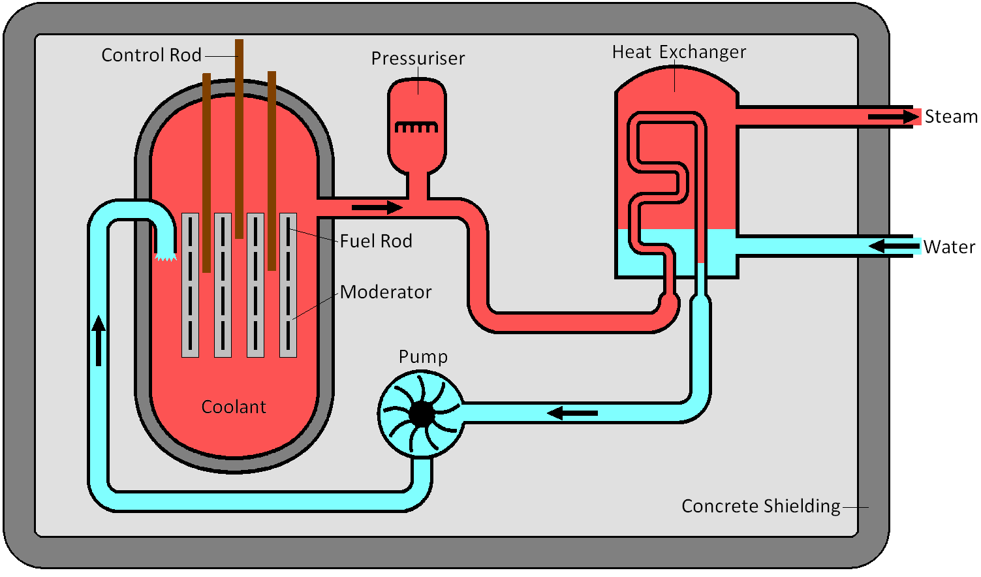Here is a diagram of a nuclear reactor in a power plant. Briefly explain what is happening

_______________________________________

_______________________________________

_______________________________________

_______________________________________

_______________________________________

_______________________________________

_______________________________________

**Batteries**

Label and use this diagram to explain how batteries produce electricity.

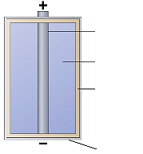___________________________________________________________________

___________________________________________________________________

___________________________________________________________________

___________________________________________________________________

___________________________________________________________________

___________________________________________________________________

The negative terminal of a battery is called the __________________________________

The positive terminal of a battery is called the __________________________________

Why do batteries run out ? __________________________________________________________________________

_________________________________________________________________________________________________

_________________________________________________________________________________________________

How does a rechargeable battery become recharged? What happens inside the battery?

_________________________________________________________________________________________________

_________________________________________________________________________________________________

_________________________________________________________________________________________________

Why is it important that batteries are disposed of correctly?

_________________________________________________________________________________________________

_________________________________________________________________________________________________

Give the advantages of having rechargeable batteries

_________________________________________________________________________________________________

_________________________________________________________________________________________________

_________________________________________________________________________________________________

Is the electricity from batteries AC or DC? __________ What does this stand for? ________________________________

What does it mean? ________________________________________________________________________________

_________________________________________________________________________________________________

**Fossil Fuel Power Stations**

Here is a diagram of a fossil fuel power station, add labels to it.

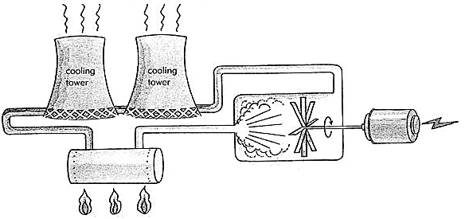

Explain what happens in the power station to produce electricity, this can be done in bullet points.

_________________________________________________________________________________________________

_________________________________________________________________________________________________

_________________________________________________________________________________________________

_________________________________________________________________________________________________

________________________________________________________________________________________________

How are fossil fuels made?

_________________________________________________________________________________________________

_________________________________________________________________________________________________

_________________________________________________________________________________________________

Are fossil fuels renewable or non-renewable? _______________________________________________

Explain your answer _______________________________________________________________________________________

_________________________________________________________________________________________________

_________________________________________________________________________________________________

Complete this box

|  |  |  |
| --- | --- | --- |
| Energy type in | Energy transformations happening | Energy type out |
|  |  | →Electrical |

**Biomass**

What are biomasses and biofuels?

_________________________________________________________________________________________________

_________________________________________________________________________________________________

Give some examples of them.

_________________________________________________________________________________________________

Explain how biomass is used to produce electricity.

_________________________________________________________________________________________________

_________________________________________________________________________________________________

_________________________________________________________________________________________________

_________________________________________________________________________________________________

Is biomass renewable or non-renewable? _______________________________________________

Explain your answer _______________________________________________________________________________________

_________________________________________________________________________________________________

_________________________________________________________________________________________________

Complete this box

|  |  |  |
| --- | --- | --- |
| Energy type in | Energy transformations happening | Energy type out |
|  |  | →Electrical |

**Wind Turbines**

How is wind created?

_________________________________________________________________________________________________

_________________________________________________________________________________________________

Explain how the wind is used to produce electricity, include a diagram.

______________________________________________________________________________

______________________________________________________________________________

______________________________________________________________________________

______________________________________________________________________________

Where are wind turbines commonly placed? Explain why these locations are chosen.

_________________________________________________________________________________________________

_________________________________________________________________________________________________

_________________________________________________________________________________________________

Is wind power renewable or non-renewable? _______________________________________________

Explain your answer _______________________________________________________________________________________

_________________________________________________________________________________________________

Complete this box

|  |  |  |
| --- | --- | --- |
| Energy type in | Energy transformations happening | Energy type out |
|  |  | →Electrical |

**Hydroelectricity**

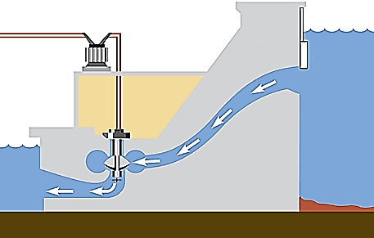Label and use this diagram to explain how hydroelectric dams are used to produce electricity.

___________________________________________

___________________________________________

___________________________________________

___________________________________________

___________________________________________

___________________________________________

___________________________________________

___________________________________________

Explain how the amount of electricity that the dam produces can be controlled.

_________________________________________________________________________________________________

_________________________________________________________________________________________________

_________________________________________________________________________________________________

_________________________________________________________________________________________________

Where can hydroelectric dams be built?

_________________________________________________________________________________________________

_________________________________________________________________________________________________

Is hydroelectricity renewable or non-renewable? _______________________________________________

Explain your answer _______________________________________________________________________________________

_________________________________________________________________________________________________

Complete this box

|  |  |  |
| --- | --- | --- |
| Energy type in | Energy transformations happening | Energy type out |
|  |  | →Electrical |

**Efficiencies**

Complete the second column in the table by finding the efficiencies of the following methods of electricity production.

|  |  |  |  |
| --- | --- | --- | --- |
| Energy resource | Efficiency | Percentage of the UK’s electricity demand it supplies | How much electricity it produced for the UK (billion kWh) |
| Fossil fuels |  | 73.90 |  |
| Biomass |  | 0.82 |  |
| Wind turbines |  | 0.75 |  |
| Hydroelectricity |  | 1.25 |  |
| Nuclear |  | 20.50 |  |

The percentages in the table do not add up to 100%. What is responsible for this difference?

_________________________________________________________________________________________________

_________________________________________________________________________________________________

Last year the UK produced about 346 billion kWh of electricity.

Use this information and the percentages from the table above to complete the last column.

Use the efficiency equation to calculate the amount of electricity each energy resource wasted last year

|  |  |
| --- | --- |
| Energy resource | How much electricity it wasted last year (billion kWh) |
| Fossil fuels |  |
| Biomass |  |
| Wind turbines |  |
| Hydroelectricity |  |
| Nuclear |  |

Norway uses almost entirely hydroelectric dams to meet their electricity needs but we only use it for about 1% of what we need. Why?

_________________________________________________________________________________________________

_________________________________________________________________________________________________

Which energy resource do you think is best for the UK? Justify your answer in terms of efficiency and environmental impact.

_________________________________________________________________________________________________

_________________________________________________________________________________________________

________________________________________________________________________________________________

**Current, Voltage and Resistance**

Explain what the following words mean:

Voltage___________________________________________________________________________________________

_________________________________________________________________________________________________

Current___________________________________________________________________________________________

_________________________________________________________________________________________________

Resistance________________________________________________________________________________________

_________________________________________________________________________________________________

What would happen if...

1) The resistance was kept the same but the voltage was increased?

_________________________________________________________________________________________________

2) The resistance was kept the same but the voltage was reversed?

_________________________________________________________________________________________________

3) The resistance was increased but the voltage was kept the same?

_________________________________________________________________________________________________

The equation that represents this is V = I x R. Complete this table

|  |  |  |  |
| --- | --- | --- | --- |
| Quantity | Equation Symbol | Units | Unit Symbol |
| Voltage |  |  |  |
| Current |  |  |  |
| Resistance |  |  |  |

Rearrange the equation to make I the subject

Rearrange the equation to make R the subject

If we connected a battery to a bulb with only one lead the bulb wouldn’t light up. Why do we need a complete circuit for the bulb to light?

_________________________________________________________________________________________________

_________________________________________________________________________________________________

**Circuit Components**

Complete the table below.

|  |  |  |
| --- | --- | --- |
| Name | Symbol | Description of what is does |
| Cell |  |  |
| Battery |  |  |
| Switch |  |  |
| Bulb |  |  |
| Buzzer |  |  |
| Voltmeter |  |  |
| Ammeter |  |  |
| Resistor |  |  |
| Variable Resistor |  |  |
| LDR |  |  |
| Thermistor |  |  |
| Diode |  |  |
| Fuse |  |  |

**Series and Parallel Circuits**

If components are set up in ‘series’ what does this mean?__________________________________________________

_________________________________________________________________________________________________

If components are set up in ‘parallel’ what does this mean?_________________________________________________

_________________________________________________________________________________________________

Draw the following circuits:

A) A battery connected to a bulb, resistor and switch in series

B) A battery connected to a resistor, diode and fuse in parallel

|  |  |
| --- | --- |
| A) | B) |

1) Three bulbs were connected in series and plugged into a battery but then the middle bulb breaks. What happens to the others?

_________________________________________________________________________________________________

2) Three bulbs were connected in parallel and plugged into a battery but then the middle bulb breaks. What happens to the others?

_________________________________________________________________________________________________

3) A battery is connected to two bulbs in a series circuit and one bulb in parallel. The parallel bulb then breaks, what happens to the others?

_________________________________________________________________________________________________

_________________________________________________________________________________________________

4) A battery is connected to two bulbs in a series circuit and one bulb in parallel. One of the bulbs in series then breaks, what happens to the others?

_________________________________________________________________________________________________

_________________________________________________________________________________________________

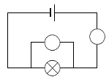

To take readings of voltage and current you must make sure that the meters are connected properly. Complete the diagram to the right.

You must connect a voltmeter in _____________________________

You must connect an ammeter in _____________________________

Label on the diagrams where you would connect voltmeters and ammeters to measure the voltage and current of each resistor.

|  |  |
| --- | --- |
|  |  |

Complete this table to describe how voltage and current behave in series and parallel circuits

|  |  |  |
| --- | --- | --- |
| Type of Circuit | Voltage | Current |
| Series |  |  |
| Parallel |  |  |

**Building Circuits**

For each of the circuits described below you must draw a circuit diagram

|  |  |
| --- | --- |
| A battery in series with 3 bulbs and a switch | A battery connected to 2 bulbs with a switch that will only turn 1 bulbs off |
| A battery with 2 bulbs in series and 1 in parallel | A circuit with 3 bulbs, a battery and a switch that controls 2 bulbs only |

Generating Electricity

**Power in Circuits**

What does the word ‘power’ mean?

_________________________________________________________________________________________________

The power in a circuit can be calculated using the equation P = V x I. Complete this table.

|  |  |  |  |
| --- | --- | --- | --- |
| Quantity | Equation Symbol | Units | Unit Symbol |
| Power |  |  |  |
| Current |  |  |  |
| Voltage |  |  |  |

Rearrange the equation to make I the subject

Rearrange the equation to make V the subject

Calculate the power of each resistor from the diagrams below.

|  |  |
| --- | --- |
|  |  |
|  |  |

Can you calculate their resistances?

**Waves of the EM Spectrum**

What do waves transfer? ________________________________

Explain what the following words mean.

|  |  |  |  |
| --- | --- | --- | --- |
| Wavelength |  | | |
| Amplitude |  | | |
| Frequency |  | | |
| Peak |  | Trough |  |

On this diagram of a wave label: 2 wavelengths, 2 amplitudes, a peak and a trough

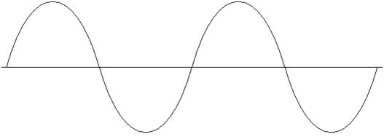

There are 7 types of electromagnetic wave, they have different ________________________ and ___________________

but they all travel at _____________________________________________

Complete the table by listing the other electromagnetic waves in order of increasing wavelength. What happens to the frequency as we go down the list? Draw the wavelength of gamma rays and radio waves.

|  |  |  |  |
| --- | --- | --- | --- |
| EM Wave | Frequency | Wavelength | Diagram |
| Gamma Rays |  | Shortest |  |
|  | l | l  l | ↑  l |
|  | l  l | l  l | l  l |
|  | l  l | l  l |  |
|  | l  l | l  l | l  l |
|  | l | l  ↓ | l  ↓ |
| Radio Waves |  | Longest |  |

The Doppler Effect can happen in sound and light waves.

In the diagram below an ambulance (with the siren turned on) is stationary between two people. What would the sound be like at A compared to B?

­­­­­­­­­________________________________________________________________________________________________

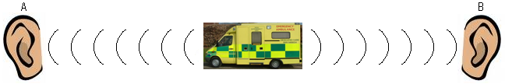

The ambulance is now moving to the left, towards A and away from B. What would the sound be like at A compared to B?

_________________________________________________________________________________________________

_________________________________________________________________________________________________

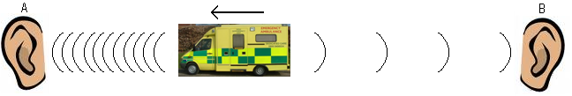

In the diagram below a stationary galaxy is being observed by two people. What would the light be like when seen from A compared to when seen from B?

_________________________________________________________________________________________________

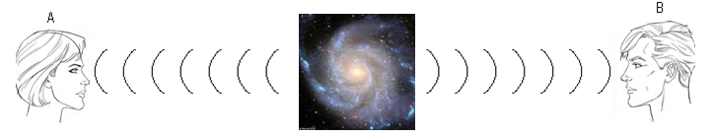

Now the galaxy is moving to the left. What would the light be like when seen from A compared to when seen from B?

_________________________________________________________________________________________________

_________________________________________________________________________________________________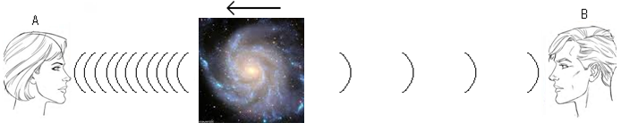

Red Shift is where the light appears _____________________ than normal light.

Blue Shift is where the light appears _____________________ than normal light.

Every galaxy we have observed from Earth has shown __________________ Shift. This means that they are moving _________________________________ and the Universe is ___________________