Subject | Physics
Level | A-level
Qualification | A-level Physics
Exam board / awarding body | OCR Specification A
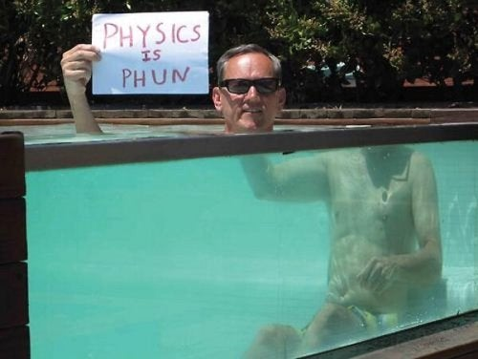
Introduction
Physics is the study of everything, from the smallest fundamental particles to universe spanning phenomena and everything in between.
So far in your studies you have been mainly focused on what we would refer to as Newtonian Physics or Macroscale Physics. In other words Physics of the real world; drop a pen and it falls under the influence of gravity, push an object and it accelerates then eventually slows down and stops due to friction and air resistance, clap your hands and sound waves radiate out from the source slowly diminishing in amplitude as they travel etc.
As we move into A-level Physics and beyond the deeper we go the more we realise that these same set of ‘rules’ don’t necessarily apply to the really small (Quantum Physics) or the really huge (Relativistic Physics). For example, gravity is caused by and affects all objects with mass. If you drop a pen it falls to the floor because of the attraction between the massive mass of the earth and the smaller mass of the pen – basic Newtonian physics, but when dealing with subatomic particles on a Quantum level the masses of the particles are so small that gravity has virtually no effect. So much so that we consider these particles to be operating in what is referred as “flat space” (Minkowski space). At the other end of the spectrum, the masses contained with whole galaxies are enough to bend light, space and even time due to the huge gravitational fields created.

Reading
The following link will take you to a free eBook version which amazon are giving access to which will help you reinforce your GCSE physics knowledge and introduce you to some A-level Physics.
https://www.amazon.co.uk/Head-Start-level-Physics-Level-ebook/dp/B00VE2NII4/ref=sr_1_1?dchild=1&keywords=alevel+biology+bridging+the+gap&qid=1588001621&sr=8-1
Link to physics specification:
https://www.ocr.org.uk/qualifications/as-and-a-level/physics-a-h156-h556-from-2015/

Research / written task
In preparation for starting A-levels we would like you to conduct a thought experiment based on these principles.
We would like you to design an experiment to measure distance, mass and velocity across three different varied scales we use in physics.
In the case of distance you should design your experiments to measure:
- The average diameter of an apple (Newtonian scale)
- The diameter of a Proton (Quantum scale)
- The distance to a distant galaxy (Relativistic scale)
In the case of mass you should design your experiments to measure:
- The average mass of an apple (Newtonian scale)
- The mass of a neutron (Quantum scale)
- The mass of a black hole at the centre of a galaxy (Relativistic scale)
And finally for velocity:
- The final velocity of an apple falling from a tree 3m high onto the ground (Newtonian scale)
- The velocity of a single alpha particle emitted from a radioactive nucleus (Quantum scale)
- The velocity of a receding galaxy (Relativistic scale)

You can use any equipment you can think of so long as the method is clear and takes into account the physics. In each of these cases we are not looking for THE correct answer what we are looking for is your ability to research around the problems encountered and attempt to come up with a solution. No doubt you will all come up with imaginative ideas which we can review and debate in the first lessons of physics at college.

