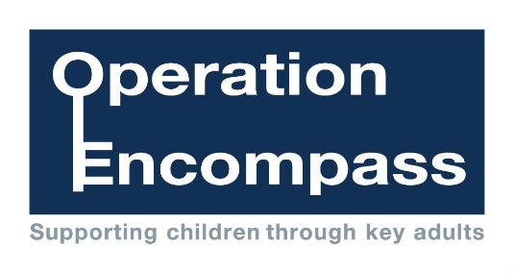

Encompass Parents Awareness Letter
Dear Parent/Carer,
This letter is to inform you / remind you that our college is participating in Operation Encompass.
Operation Encompass is a unique Police and Education early intervention safeguarding partnership which ensures that a child/ young person's college is informed, prior to the start of the next college day, that there has been an incident of Domestic Abuse or any incident to which the child/ young person has been exposed in which they are considered to be vulnerable to harm, and which might then have an impact on them in college the following day.
Each college is informed of all such incidents, not just those where an offence can be identified or those which are graded as high risk. The partnership recognises that all incidents of Domestic Abuse/ vulnerability can be harmful to children and young people.
This information will be shared throughout the year, including holidays and weekends. Information will only be shared with the college by the police where it is identified that a young person was present, witnessed or was involved in a domestic abuse incident.
A nominated member of staff, known as a Key Adult, has been trained to liaise with the police. At Nelson and Colne College Group our Key Adults are Helen Gray, Sam Kelly, Sarah Morley and Rhianne Heaton. They will be able to use information that has been shared with them, in confidence, to ensure that the school makes provision for possible difficulties experienced by children or their families. The Key Adults will keep this information confidential, and will only share it on a need to know basis, for instance, to teaching staff for the child or young person. It will not be shared with other school students.
Operation Encompass was first introduced in Plymouth in February 2011, and has proved very effective in providing appropriate and timely support to young people affected by domestic abuse. This initiative has been implemented across the whole of the Lancashire Police area. If you would like some more information about it, you can view it online at www.operationencompass.org.
We are keen to offer the best support possible for our pupils and a recent review of Operation Encompass showed that it is beneficial and supportive for all those involved.

Yours sincerely,

