November 2023
Dear Parent / Carer(s)
I am thrilled to welcome you as parents / carers of students who have entered the world of further education, having chosen to study A Levels with us here at Nelson and Colne College. I must start by congratulating you and your young person for choosing Nelson and Colne College for the place to study A-Level subjects. It really is an extraordinary place to study. Each year, we continue to be a beacon for educational excellence, and this is achieved by combining phenomenal teaching with hard work and high expectations. I’m delighted that our college was recognised as OUTSTANDING by OFSTED in March 2022 – please do read the full report here: Ofsted Report - March 2022(1).PDF
The course information contained in this “parent pack” is aimed at giving you useful practical information so that you can support your young person to settle in and make the most of their time here at Nelson and Colne College.
You will find the following information in this parents’ welcome pack:
- Your young person’s individual timetable
- Their Tutor contact details
- A calendar of key events
- An explanation of the A Level study programme
- Our college expectations and the A Level mind set

I hope you will find this parent information pack informative and useful. However, if you do have any queries or concerns as the course develops, please do contact your young person’s personal tutor (whose contact details are provided as part of this pack), who will always be willing to help and offer guidance where necessary.
During the academic year, there are some planned drop-down days where students access their lessons and learning on Microsoft Teams. This is mainly with the aim of developing and practising key digital skills as well as preparation for Higher Education where online learning is still very much a feature. If our students do not have access to a PC, tablet or laptop and they are in receipt of the college bursary or have additional learner support needs, they may be able to loan a college laptop. Students should speak to their personal tutors in the first instance.
I am extremely confident that your young person will enjoy their A Level studies here at Nelson and Colne College. It is an exciting stage of their lives and the start of their future as a young adult.
We look forward to supporting them on their journey and celebrating their success in August 2025.
Yours sincerely,
Fionnuala Swann
Assistant Principal – Academic Curriculum I Centre Principal – Nelson Campus

General Information

Location:
Nelson & Colne College
Scotland Rd
Nelson
Lancashire
BB9 7YT

Absence Line: 01282 440 293
Students Services: 01282 440 209

TERM DATES AND HOLIDAYS 2023 - 2024

Winter term
Monday 4th September 2023 – Start of term
Thursday 19th October 2023 – Classes finish for half term
Monday 30th October 2023 – Students return
Thursday 21st December 2023 – End of term

2024

Spring term
Monday 8th January 2024 – Start of term
Friday 9th February 2024 – Classes finish for half term
Monday 19th February 2024 – Students return
Thursday 28th March 2024 – End of term

Summer term
Monday 15th April 2024 – Start of term
Friday 24th May 2024 – Classes finish for half term
Monday 3rd June 2024 – Students return
Wednesday 26thJune 2024 – Students complete (end of academic year)

A LEVEL
2023-24
Wk No | Week Beginning | Topic | Formative &  Summative Assessments
1 | 04/09/2023
2 | 11/09/2023
3 | 18/09/2023
4 | 25/09/2023 |  | KAP1
5 | 02/10/2023
6 | 09/10/2023
7 | 16/10/2023 | Friday 20th = INSET day
 | 23/10/2023 | Half Term
8 | 30/10/2023
9 | 06/11/2023
10 | 13/11/2023
11 | 20/11/2023 |  | Mock week (Y1 and Y2)
12 | 27/11/2023
13 | 04/12/2023 |  | KAP 2
14 | 11/12/2023
15 | 18/12/2023 | Friday 22nd = Get yourself sorted
 | 25/12/2023 | Christmas Break
 | 01/01/2024 | Christmas Break
16 | 08/01/2024
17 | 15/01/2024
18 | 22/01/2024 |  | KAP3
19 | 29/01/2024 | Conference day Thursday 1st Feb
20 | 05/02/2024 | Thursday 8th = eLearning CPDL day
 | 12/02/2024 | Half Term
21 | 19/02/2024
22 | 26/02/2024
23 | 04/03/2024 |  | Mock week (Y2)
24 | 11/03/2024
25 | 18/03/2024 |  | KAP4
26 | 25/03/2024 | Friday 29th = Bank holiday
 | 01/04/2024 | Easter Break
 | 08/04/2024 | Easter Break
27 | 15/04/2024
28 | 22/04/2024
29 | 29/04/2024 | Tuesday 30th = CPDL
30 | 06/05/2024 | Monday 6th = Bank holiday | KAP5
31 | 13/05/2024
32 | 20/05/2024
 | 27/05/2024 | Half Term
33 | 03/06/2024
34 | 10/06/2024
35 | 17/06/2024 |  | Mock week (Y1)
36 | 24/06/2024 | Wednesday 26th = End of Year 1 | KAP6 (only Y1)
37 | 01/07/2024
38 | 08/07/2024

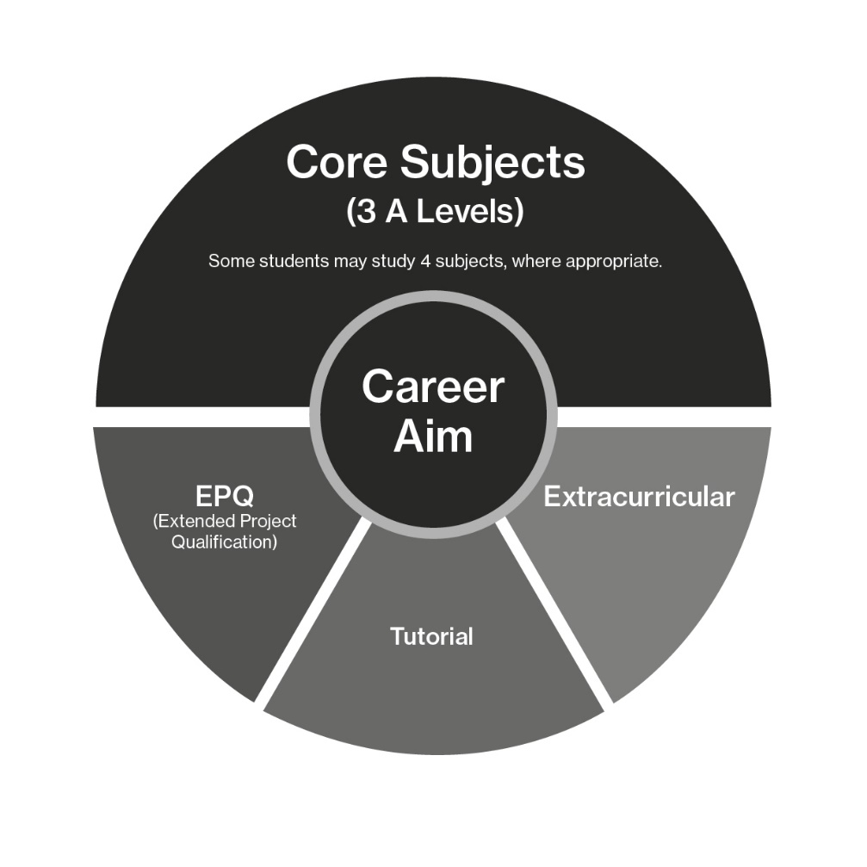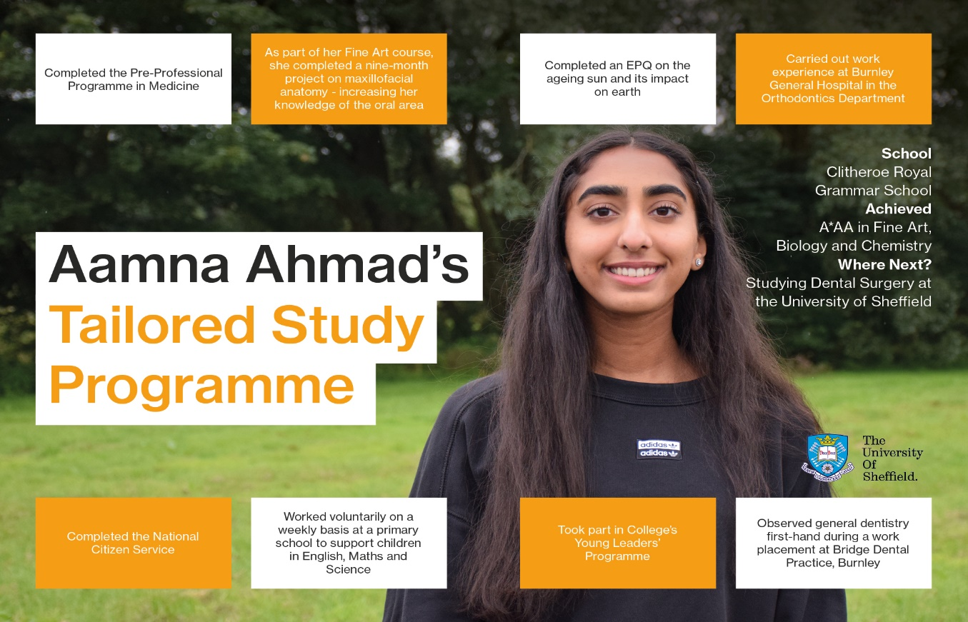

Developing Skills
In addition to the three A Level subjects, all A Level students have a compulsory “APPS” session every week with their tutor. This is designed to support the students’ career aim and includes a focus on wider academic skills such as teamwork and communication, problem solving, and developing extended writing. From term 2, students will be given the opportunity to work on completing a research project which leads to an Extended Project Qualification (the EPQ). This will be an independently created project on a subject of the student’s choice. The EPQ can be a dissertation, a field study, an artefact or even a performance. The project is designed to equip students with the ‘little bit more’ which is highly valued by universities and even carries UCAS points to support students in their progression to higher education.
Developing digital skills
You will notice on your young person’s timetable that there is 1.5 hours of timetabled DDL. This stands for Directed Digital Learning; students are expected to work through MOOCs (through open learn) in term 1 and then develop their essential digital skills in term 2 and 3. They are not actual timetabled sessions as the emphasis is on “independent” work. Tutors will, however, check completion and certificates are required to be uploaded to their tutorial Teams site.
Extra-curricular Programme
To help students secure the best place at university and develop the skills that employers and universities are looking for, as well as support our students’ health and well-being, we ask that all students sign up to at least one extra-curricular activity. These activities are designed to help students stand out from the crowd, build confidence and independence as well as gain new hobbies and interests. For example, students may wish to improve leaderships skills, volunteer for a good cause, or develop skills for public speaking. A copy of the current extra-curricular timetable is available through the live link via the ‘MyDay’ app (or click the link below). Please do discuss this with your young person and find out which activity/activities they are participating in.
NCC ExtraCurricular Timetable 220923[94] copy.pdf
Professional Skills
Pre-Professional Programmes
We also offer a range of pre-professional programmes which students can take alongside their A Level studies. These unique and innovative schemes are career focused programmes aimed at helping students to make an informed choice about their future, while encouraging breadth and depth of study and research in your chosen career path.
The Pre-Professional programmes offered currently at NCC are:
- Pre-Business
- Pre-Law
- Pre-Med
- Pre-Psychology
- Pre-Teaching
Studying Pre-Professional courses alongside your core study programme is designed to give you the edge for university applications in what are quite often extremely competitive and challenging degree and career pathways. Do please speak to your young person and discuss whether this is something that they could be doing.
Raising Aspirations & Applying for the Best Universities
We have excellent links with universities and other partners, offering a range of additional admissions opportunities for students, to support them in their applications to the best universities in the country. Your young person’s tutor will provide information about the various different partnerships and discuss eligibility criteria. Just some of these opportunities include:
Scholars’ programme
See our prospectus for details of the Scholars’ programme:
https://www.nelson.ac.uk/NCC%20Prospectus%202024%20-%202025%20FINAL%20DIGITAL%20VERSION.pdf
College Expectations and Code of Conduct
At college, we have high expectations of our learners. We explain to them that they are in an adult environment and that they have an obligation to behave like young adults, now that they have moved away from the school environment. It would be really helpful if you could help us reinforce these expectations to ensure that we continue to exhibit an exemplary learning environment. You will notice that there is particular reference to online learning under the section “are you ready to learn?”. It is really important that our students treat their online lessons the same as the lessons which are held at college on site. We expect students to be present, punctual, to participate, to have their cameras on to aid interaction and professional backgrounds in place.

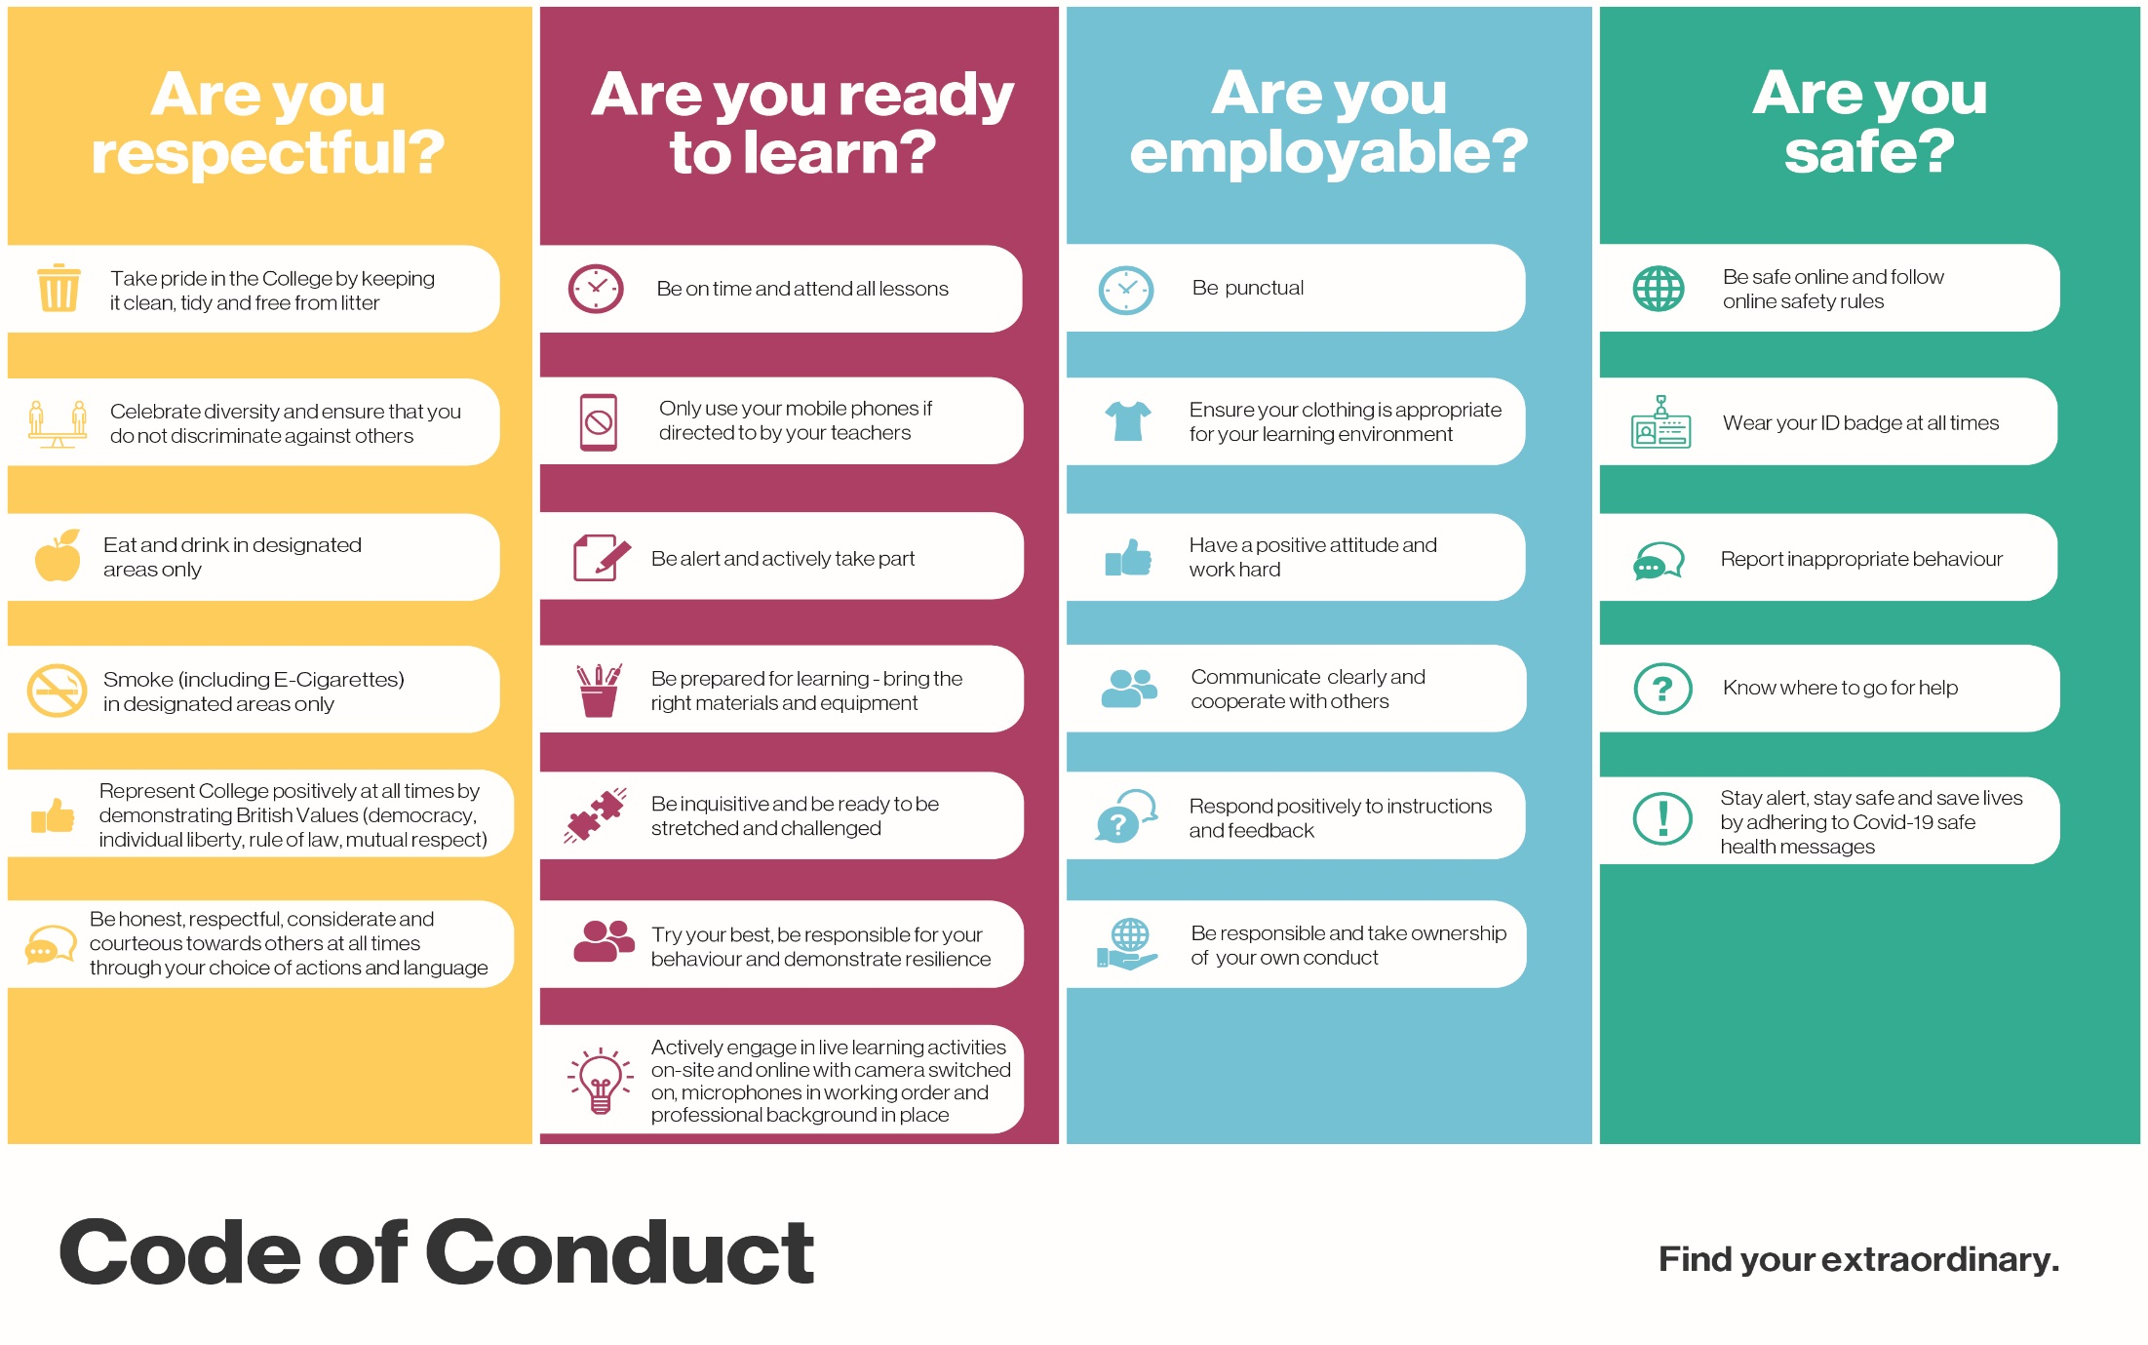
The A Level Mind Set
At Nelson & Colne College, we absolutely believe that intelligence is not fixed; that our students could all potentially achieve 3 A* grades, as long as they embrace a growth mind-set. The fact that we are the top college in Lancashire for the progress that our students make is a reflection of this belief in the growth mind-set. Ask your young person to complete the questionnaire below and try to encourage them to adopt a growth mindset.

